

Personal Lines

Workflows & Procedures

*for*

Acrisure Partners West Coast Insurance Services, LLC

V.1.9.2025

# How to Use this Document

|  |
| --- |
| This document contains valuable information relevant to the usage of EPIC, including **Epic Basics**, day-to-day **Workflows**, and **Job Aids. DO NOT PRINT THIS DOCUMENT.**  For optimal usage:   * Click the **View** menu at the top in the Microsoft Word toolbar. * Checkmark **Navigation Pane**      * The left pane will open and show a listing of topics.      * Click on the topic to jump to that section/page. * Hyperlinks within the document will lead to specific pages or Job Aids.      * Some hyperlinks will connect to a webpage outside of the document. |

# Epic Browser

## Logging in

|  |
| --- |
| 1. Open a web browser.    1. Chrome    2. Edge 2. Enter URL:    1. **Production/Live**: <https://acris03.appliedepic.com/#/>    2. **Test/Training**: <https://ve061t1web.appliedepic.com/#/> |

## Browser Tabs

|  |
| --- |
| Browser tabs will open at the top when accounts are located and selected    Use browser tools like Tab Grouping and Zoom, if desired.  To prevent connection issues, close out of a client by clicking the X above the Logout button, NOT the x in the browser tab |

## Connection Suite & New Functionality Popups

|  |
| --- |
| The Connection Suite is required to ensure full functionality and connection within Epic Browser. Acrisure IT manages all updates in the background for the Connection Suite Plugin. **Ignore these popups.** If you are receiving an error, follow the instructions to hard shutdown to ensure there’s a clean connection to all services run on your computer. If you are experiencing functionality issues after shutting down, submit a ticket to [support@acrisure.com](mailto:support@acrisure.com).  ***Reminder: A hard shut down of your computer should be done at the end of each workday.***    ningIf you are interested in learning what changed in recent updates, click the link to view the Release Notes. |

## Logging out of Epic

|  |
| --- |
| **\*\*IMPORTANT\*\***  When **closing out of Epic,** click the **LOGOUT** button at the top right in the blue Options Bar. **Do not X out.** Epic will not close properly which may cause issues when signing back in again.  **NO** |

**Shutting Down Desktop**

|  |  |  |  |  |  |  |  |  |
| --- | --- | --- | --- | --- | --- | --- | --- | --- |
| **\*\*IMPORTANT\*\***  Log out of Epic and SHUT DOWN your computer **at the end of each workday.**   |  |  | | --- | --- | | 1. In Epic, click the Logout Button |  | | 1. Shut down the computer by clicking the Start Menu |  | | 1. Click Power |  | | 1. Click Shut Down |  | |

# EPIC BASICS

## Home Base

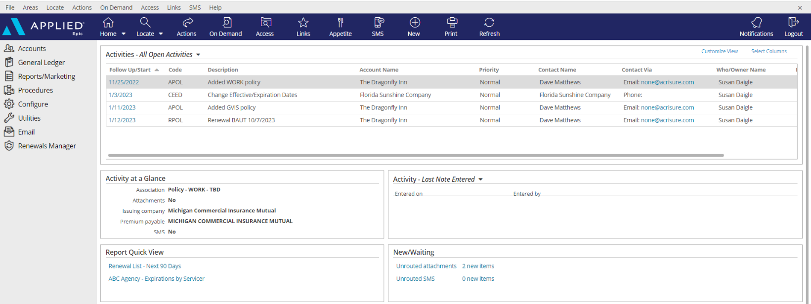

|  |
| --- |
| 1. **Open Activities** (suspense, follow up, to-do list)    * Use “**Select Columns**” to add columns to your view.    * The position of the columns can also be changed by clicking and dragging the column headers to the desired location.    * Sort columns in ascending or descending order by clicking on the column header 2. **Activity at a Glance** – displays information about the highlighted activity 3. **Activity Tasks** OR **Last Note Entered** – when a task within an activity is assigned to you, the task will appear here but only if the activity above, associated with the task, is highlighted. The view can be changed from “Activity – Tasks” to “Last Note Entered” by clicking the dropdown arrow and selecting the appropriate option. 4. **Report Quick View** – Created reports can be sent to Report Quick View for easy access. Just click the link and the report will open. Data displayed is in real time and will be refreshed as of the date it is opened 5. **New/Waiting** – If your agency has opted to use Front End Scanning, scanned mail can be accessed by clicking the “Unrouted Attachments” link. The number of items in your “inbox” will also display. 6. **Navigation Panel** – Items listed here will direct you to distinct parts of Epic or to the client’s account. Items available will change depending on which screen is being utilized. This is known as the “View” panel. 7. **Blue Options Bar** – Each icon contains action options, which will change depending on which screen is being utilized. Think of this as the “Do” bar. 8. **Log Out button** – Clicking this button will close all the open screens/windows and log out of Epic. 9. **Locate** – Click the dropdown arrow to see a list of the last 20 accounts accessed |

## Activities & Tasks

|  |
| --- |
| **Activities in Epic perform three essential functions:**   * Add a record to the client file for the action performed * Allow a follow up or Open Activity as a reminder to do something at a current or future date * Permanently document the file with the use of Notes within Activities   **Tasks in Epic can supplement an activity:**   * Can be used as a to-do list related to that activity or to share work with another user * Task owners and start dates can be independent from the activity   ***NOTE: Activities/notes cannot be deleted or moved to another account. While the activity description is editable, the notes area cannot be altered and is date/time stamped.*** |

### Manage Activities from Home Base

|  |  |
| --- | --- |
| **Select Columns** | A close up of a sign  Description automatically generatedCheck or uncheck the columns desired to reflect within the Home Base View |
| **Customize View** | A screenshot of a computer  Description automatically generatedAllows the addition of other Employee activities to reflect within your own open  activities list (if given permission) |
| **Right Click to Manage** | * **Close Activity** – *follow up action is completed* * **Add Note** – *add notes related to the process which is still pending* * **Add Task** – *assign a portion of the activity process to someone else to work on* * **Change Follow-up Date/Time** – *if the deadline for completing the activity can be moved* * **Change Who/Owner** – *reassign the activity for someone else to take care of, which will move to their Home Base* * **View All Notes** – *Read all notes related to a specific activity process*   A screenshot of a computer  Description automatically generated   * **Take Ownership** – *If the activity is assigned to another person or a work group, it can be reassigned to yourself*   ***Note: multi-select activities (CTRL + Click) to apply the above actions to multiple activities at one time.*** |

### Manage Tasks from Home Base

|  |  |
| --- | --- |
| **Customize View** | A screenshot of a computer  Description automatically generatedAllows the addition of other Employee tasks to reflect within your own open  activities list (if given permission) |
| **Right Click to Edit** | * **Description** * **Owner** *–* *reassign the activity for someone else to take care of, which will move to their Home Base* * **Status** *– mark as cancelled, completed, in-progress or not applicable as needed* * **Start/Due date**s – *amend if the deadline for completing the task must be moved* * **Add Note** - *add notes related to the process which is still pending*A screenshot of a computer program    Description automatically generated |

## Client Accounts

### Locate Account

|  |
| --- |
|    * Click the **Locate** button to **search** for existing clients   **Locate Options:**   * + **Account/Business Name** – *contains full or partial account name*   + **Claims: Additional Party** – by involvement type, name, or phone number   + **Insurer Claim#** - must be exact & complete   + **Internal Claim#** - must be exact & complete   + **Date of Loss** – *range*   + **Last name, first name** – *begins with* and will search account detail name field and individual contacts   + **Lookup Code** – *begins with*   + **Phone Number** – must be exact & complete   + **Policy #** - *contains*   + **Prior Account ID** – *begins with* (from your prior system)   + **Relationship** – relationship type and then account name   + **Submission ID** – *begins with* (in marketing)   + **Vehicle Registration Number** * Click the **Locate** button to **add new** client accounts. * Click the **drop-down arrow** on the Locate button to access the last 20 accounts accessed (includes client accounts, employee accounts, company accounts, etc.)   A screenshot of a computer  Description automatically generated |

### Close Out of an Account Record

|  |
| --- |
| Locating and selecting an account will create a new tab in the browser. **Close the account record by clicking the X above the Logout button** NOT by clicking the x within the tab itself.  A screenshot of a computer  Description automatically generated |

## Contacts

### Overview

|  |  |
| --- | --- |
| **Individual Contact** | This is an additional individual contact (person) on the account. By choosing an individual contact, additional fields are made available, such as date of birth, SSN, marital status, driver's license number, etc. Click the lock to the right of the PII fields to secure the field, making it private. |
| **Primary Contact** | This is an **individual contact** that should be selected as the primary contact for the account. To make a contact **Primary,** click **ACTIONS** **> Change Primary Contact**. The Primary Contact is displayed in the Rolodex Card on the bottom left corner of the client’s account. |
| **Category** | Contacts are categorized based on their relationship to the Account: Contact Only—Policy Only—Both Contact & Policy |
| **Description** | Add **Description** to best represent the position or role of the Contact (i.e., owner, manager, etc.) Select the appropriate description (s) for each Contact. This information is used for tracking and reporting. |
| **Contact Classifications** | **Be sure to select** the appropriate contact classification. DM=Decision Maker; PC=Primary Contact   |  |  | | --- | --- | | Acrisure Webinars | 401k Plan Administrators | | __User - Benefits Technology | _EB Compliance Newsletter | | __User - CSR24/Portal | _EB Contract Signer | | __User - HR Portal | _EB Eligibility Contact | | __User - Indio | _EB HRLS Compliance Summit | | _User Insite Portal | _EB Payroll | | _User - Succeed | _EB Plan Admin | | _User – Zywave | _EB Payroll | | _User – Zywave LMS | _EB Plan Admin | | _Certificates | _EB Payroll | | _Commercial (DM) | _EB Plan Admin | | _Commercial (PC) | _Risk Management (PC) | | _Cyber (DM) | _Safety (PC) | | _Cyber (PC) | _Surety (DM) | | _EB (DM) | _Surety (PC) | | _EB (PC) | _Work Comp (DM) | | _EB Compliance | _Work Comp (PC) | |

### Additional Contacts

#### Add Individual Contact

|  |
| --- |
| 1. From the client’s account, click **Contacts** in the left navigation pane. 2. Click the **ADD** button.   A screenshot of a computer  Description automatically generated   1. Select the **Individual** radio button 2. Enter First Name, Last Name 3. **Category:** Indicate whether contact only, policy only, or both contact & policy 4. **Description:** Select the appropriate description for this contact 5. Enter the address. If the account address is the same as the contact address, check the box for Use Account Address 6. Enter phone number (indicate if mobile) and email address - ***NOTE: Email is a required field***. If the contact does not have an email address, enter [none@acrisure.com](mailto:none@none.com)   A screenshot of a computer  Description automatically generated   1. Click **DETAIL** to add additional information such as date of birth, SSN, personal info, etc.   If not, click **FINISH**. |

#### Inactivate a Contact

|  |
| --- |
| 1. From the client’s account, click **Contacts** in the left panel 2. Make sure you have Inactivated ANY Indio or CSR24 Portal Login 3. Double click on the **Contact** you wish to Inactivate. 4. To the Right, select **EDIT**   A group of words on a white background  Description automatically generated   1. Scroll to the bottom and under **Description** choose **1 – INACTIVE CONTACT**   A screenshot of a computer  Description automatically generated   1. Select **Save Contact Summary** 2. Little x out of the contact entry 3. Under the Description Column the Contact is listed as INACTIVE CONTACT   A screenshot of a computer  Description automatically generated |
|  |

## Sticky Notes

|  |
| --- |
| 1. Add a sticky note by clicking the **NEW** button in the blue Options Bar within the Client Account   A screenshot of a computer  Description automatically generated   1. Enter note 2. Collapse the note by clicking the double up arrows 3. Manage the Sticky Note by clicking the three vertical dots   A screenshot of a computer  Description automatically generated   1. Delete the Sticky Note by clicking the X 2. Add a New Sticky Note by clicking the + |

## Email

### Email from the Distribution Manager

|  |
| --- |
| As part of the normal workflow, when the ACORD form is ready to print/send, utilize the **Distribution Manager** to send documents.   1. From the **Distribution** Tab, set delivery option to **Email** 2. The **From** field defaults to your email address, however the sender can be changed 3. Add **Signature** (should default) 4. Add more than one recipient, cc, or bcc 5. Enter body of the email with full HTML functionality (change font size/color, add logos, pictures, change alignment, etc. 6. **A screenshot of a computer     Description automatically generated**If the documents need to be sent to multiple recipients, use the **Apply To** link to apply the email to all recipients 7. Click **Finish** to send |

### Email from Attachments

|  |
| --- |
| 1. From your client file, go to **Attachments** in the Navigation Panel 2. Highlight the attachment(s) to be sent *(Hold down the CTRL key to multi-select)* 3. Right-click or do an **Action > Send Via Email** 4. Populate your recipients, subject, body 5. A screenshot of a computer     Description automatically generated**Send** |

## Faxing

### From Distribution Manager

|  |
| --- |
| As part of the normal workflow, when the ACORD form is ready to print/send, utilize **Distribution Manager** to send documents.   1. From the **Distribution** Tab, set delivery option to **email** 2. Select a “**From**” email address 3. In the “**To**” field, type **1[fax number]@efaxds.com** 4. Enter **Subject** line (required) 5. Enter message, if needed      1. Click **FINISH** to send. |

## Attachments

|  |
| --- |
| There are various ways to create or attach existing documents to a client account.   * Attach an existing document * Create a new document * Generate a blank fillable acord form   **\*\*PLEASE FOLLOW THE ATTACHMENT NAMING CONVENTION PROTOCOL** **JOB AID****\*\*** |

### Add Documents

#### Add Existing Documents

|  |
| --- |
| 1. Click the plus (+) sign to **Add** 2. Select **Existing file** (from outside of Epic) 3. **Continue** 4. Select **Choose Files**    1. Select your document from your desktop, local or network drive    2. Click **Open**    3. Click **OK** 5. Attach to will automatically appear    1. Use the dropdown to select **activity** and use the lookup to select the applicable activity    2. Check the box to **Mark as an Important Policy Document** as desired *(this feature can be used to quickly find important documents such as policy dec pages, audits, endorsements or other policy documents)*    3. Fill in a **description** *(according to the naming convention)*    4. Select your **folder** (if not defaulted)    5. Check the box to make **Client** accessible *(if client uses CSR24 to obtain their documents)*    6. **Finish** |

#### Drag & Drop Existing Documents

|  |
| --- |
| 1. Drag your document to & release on an activity *(either open to full details or in list view)*    1. Attach to will automatically appear with the activity you selected to drop to    2. Check the box to **Mark as an Important Policy Document** as desired *(this feature can be used to quickly find important documents such as policy dec pages, audits, endorsements or other policy documents)*    3. Fill in a **description** *(according to the naming convention)*    4. Select your **folder** (if not defaulted)    5. Check the box to make **Client** accessible *(if client uses CSR24 to obtain their documents)*    6. **Finish**   **Drag & Drop works with documents in Outlook (classic version only), network folders, desktop, etc.**  Select the appropriate access level for security  Check the Client Accessible box to make an attachment available in the client portal (CSR24) |

#### Epic Plug-In for Existing Emails

|  |
| --- |
| Attaching Email when Sent   1. Click NEW Email Button in Outlook 2. Checkbox Attach to Epic Box 3. A screenshot of a computer     Description automatically generatedAdd Client Email Address in the To Field, Type Title in Subject Line and Type out body of email. 4. When finished with email and all relevant documents are attached, click SEND. 5. Attach To Tab will open in Browser 6. Click Magnifying Glass to the right of the Code Field to Locate Client. Click Finish Once Account is found. 7. Under Attach To – Identify and select the appropriate dropdown (Policy or Activity) for where the Email and/or documents should be attached to.   A screenshot of a computer  Description automatically generated   1. Once all required fields are completed, Click Finish and email will be routed into Applied.   Attaching Existing Email   1. Right Click on existing email in Outlook and select Attach to Epic 2. Attach to Tab will open in Browser 3. Click Magnifying Glass to the right of the Code Field to Locate Client. Click Finish Once Account is found. 4. Uncheck the “Delete original after attaching” box 5. NOTE: If this box does not get un-checked, your email will be deleted from your outlook.   A screenshot of a computer  Description automatically generated   1. Under Attach To – Identify and select the appropriate dropdown (Policy or Activity) for where the Email and/or documents should be attached to. 2. Once all required fields are completed, Click Finish and email will be routed into Applied. |

#### AI Email Summarization

|  |
| --- |
| Let Epic’s AI Email Summarization tool add activity notes while simultaneously attaching your email.   1. Drag your document to & release on an activity *(either open to full details or in list view)*    1. Select **Summarize** to summarize a thread    2. OR check the box to include **Latest Message Only** and then select **Summarize** 2. The summarized notes will auto-populate and should be reviewed to confirm the results are valid and as expected *(you may add, delete or amend the notes as needed)* 3. Complete your attachment **Description,** select appropriate folder *(if not defaulted)* 4. **Finish**   **A screenshot of a computer  Description automatically generated** |

#### Add New Documents from Templates

|  |
| --- |
| To select a form letter:   1. Click the Attachments area in the Client account 2. Click the **ADD** button (+) 3. Select Document – click Continue   A screenshot of a computer  Description automatically generated   1. Select a **Template Folder** (i.e., Commercial) 2. Select the form letter from the dropdown list   A screenshot of a computer screen  Description automatically generated   1. Under the Contact tab, check the recipient of the letter 2. Click the Policy/Claim tab and select a policy or claim to reference in the letter      1. Click **Continue** 2. Change attachment description if needed 3. Click **FINISH** 4. Epic data will merge with Microsoft Word and letter will open 5. Update letter as needed. When finished, click the X at the top right to close the Word document 6. Click **YES** to save document as an attachment 7. The Attachment will be saved in WORD format; however, if sending the letter via email or to eSignature, be sure to Convert to PDF first, as follows:    1. Right Click on the WORD attachment    2. Select “Convert to PDF”    3. Click **FINISH** 8. From the attachments area, find the PDF version of the form letter, right click and either “Send to eSignature” for DocuSign, or “Send Via Email” to send from Outlook. 9. If “Send Via Email” an attachment screen will pop up. The description can be changed for the email attachment if needed. |

#### Generate a Form Fillable Acord Application

|  |
| --- |
| 1. Navigate to the Home Base 2. Select **Access > eForms** from the blue options bar    1. Highlight the desired form    2. Continue 3. The form fillable application will download to your computer   A screenshot of a computer  Description automatically generated |

### Attachment Actions

|  |  |
| --- | --- |
| Click **ACTIONS**   | * **Convert to PDF** – *Converts any document to PDF format in two clicks; can also combine multiple documents into one PDF document* * **Distribute Attachments** – *Uses Distribution Manager to email documents to client contacts* * **Edit Attachment Detail** – *Edit description, association, access levels, and folder* * **Move Attachment** – *Move attachment to another account, folder, etc.* * Policy Checking (Do Not Use) * **Reactivate Attachment** – *Used to remove an attachment from the Inactive area* * **Send via CSIO eDelivery –** NOT APPLICABLE * **Send to eSignature** – *Launches DocuSign* * **Send Via Email** – *Emails attachment through Outlook* |

### Find and view attachments/documents

|  |
| --- |
| * **Important Policy Documents:** In the attachments list view, click the link “Show Only Important Policy Documents” to view all documents being previously marked as “Important”   To revert to all documents, click “Show All Documents.” This link serves as a filtering tool.     * **Filters:** Choose a filter: Ex. Attached within last 6 months.     Filtering by multiple Types of Business is also an option and can be set as the filter default  A screenshot of a computer  Description automatically generated |

### Folder View

|  |
| --- |
| * Use folders to organize client documents (Optional) * Folder structure is pre-determined by Acrisure * To see documents in folders, click Attachments view and select Folder View from the drop-down list * Select the folder (i.e., Correspondence, Invoices, Policies, etc.) * Click the expander in the left panel to see sub folders   A screenshot of a computer  Description automatically generated |

### Access Filter

|  |
| --- |
| A screenshot of a computer  Description automatically generated  The Access button will filter items for a specific policy, activity, transaction, within the **Client’s Account**  **Example:**   1. From the policy screen, select a **policy** 2. Click the **Access** button 3. Select an option:    * **Activities** = displays all the activities associated with the selected policy    * **Attachments** = displays all the attachments associated with the selected policy    * **Claims** = displays all the claims associated with the selected policy    * **Opportunities** = displays all the sales opportunities associated with the selected policy    * **Services** = displays all the services associated with the selected policy    * **Proofs** = displays all the Proofs associated with the selected policy    * **Transactions** = displays all the transactions associated with the selected policy    * **Auditing** = displays all the documents a client has access to via the CSR24 Portal    * **Notifications** = displays notifications related to the selected policy |

## Policy Basics

**Determining your Issuing Company (ICO) and Premium Payable Entity (PPE)**

|  |
| --- |
| * **ICO:** The Issuing Company is the writing company that is displayed on the policy DEC page. * **PPE:** The Premium Payable Entity should be the carrier or broker that is paying direct bill commission or invoicing for premium. * **Example:**   + ICO = Travelers Property Casualty Company of America   + PPE = THE TRAVELERS COMPANIES INC   A close-up of a document  Description automatically generated  A screenshot of a computer  Description automatically generated |

**Select the Correct ICO and PPE**

|  |
| --- |
| **When setting up a policy, it is critical to select the correct writing/issuing company.**   * Use the dropdown to select the correct Issuing company * Doing so will default the correct Premium payable entity * Use the dropdown to select the correct Payable contract   **If the correct payable contract is not selected, the wrong location could be paid resulting in delay of payment being applied and potential NOC.** |

**When your PPE is a Broker**

|  |
| --- |
|    * Use the dropdown to select the correct Issuing company * Change the Premium payable from CA to BR and select the appropriate Broker * Use the dropdown to select the correct Payable Contract by clicking the dropdown arrow   **If the correct payable contract is not selected, the wrong location could be paid resulting in delay of payment being applied and potential NOC.** |

|  |
| --- |
| **Data Standards**  **ICO**   * The Epic ICO field should match the policy DEC page. * If the final company has not yet been determined, you may use the QUOTE1 ICO as a placeholder, but you must update when you bind coverage along with the policy #. * If the issuing company you are looking for is not available in Epic, you can submit a request to Regional Enterprise Applications (REA).   **PPE**   * The PPE must match the carrier/broker invoice or commission statement * The PPE field is critical because if the wrong PPE is selected it could lead to the wrong carrier getting paid resulting in cancellation, delayed commission posting could impact producers, and carrier/reporting analytics could be incorrect * The accounting team may enter a $PUR activity for you to update the PPE if it is not entered properly which will indicate to you a policy update is needed |

### Service Summary Rows and Stages

|  |
| --- |
| Service Summary Rows **(SSR)** provide a chronological order of services provided to the account. Each service/action taken to a policy will be reflected in the service summary row in the order of most recent.  When viewing a policy in Epic it is essential to view the most recent Service Summary Row.  From the policy view screen in a client account click to highlight the policy. Once doing so the most recent Service Summary Row will highlight. To view a different service summary row, click to highlight.  **For example**: Service Summary #2 *will* display the policy details for the endorsement effective on the date noted on the Service Summary row. While Service Summary Row #1 *will not* reflect the added vehicle since Service Summary row #1 is the details of the policy when the policy term began.    ***NOTE: When viewing a multi-line package, click to highlight one of the lines under the policy header to view the Service Summary Row. The screenshot below indicates if CPK1 is selected, there are no SSR’s displayed.***  A screenshot of a computer  Description automatically generated  ***Single click on a line of business then the most recent Service Summary Row will default.***  ***See below.***  A screenshot of a computer  Description automatically generated  Having multiple Service Summary Rows to view, allows us to be able to see the policy details at any given date during the term. We can use these details to compare the changes made between one Service Summary Row and another. To compare Service Summary rows, go to Blue Options bar and click **ON Demand>Service Summary Comparison**  The list below explains what the various stages represent. ***It is imperative to be sure the correct status of the policy is representative of the current stage of the policy details.***   * **In Process** – Policy details are not complete, and the application is open for edits * **Submitted** – It has been sent to the carrier for action and the application or endorsement is now locked down * **Issued** - Policy or endorsement has been issued by the carrier or confirmation of coverage received from carrier * **Not Issued** – Use only if policy or endorsement has not been issued by the carrier and it was previously in submitted stage * **Cancelled** – Cancellation has been confirmed by the carrier * **Migrated** – One time use for conversion and simulates the stage of submitted |

### Copy Policy

|  |
| --- |
| Use this workflow when a copy of an entire policy needs to be moved within the same account or to another account.   1. Highlight the policy needing to be copied 2. Click **ACTIONS > Copy Policy** 3. Choose: To Another Account - or - To Current Account 4. Enter the Lookup Code of the Other Account (if copying To Another Account) 5. Fill in the structure and policy detail 6. Click Detail 7. Policy has now been copied. Enter additional details as needed. |

### Print Application

|  |
| --- |
| 1. With the policy selected, click **ACTIONS** **> Review Application** 2. Click the **Distribution** Tab    1. Select Print as the distribution method    2. Click the **Download & Print** button     Download will be added to your **Downloads Folder** on your computer. This will allow the documents to be printed locally or to be printed from the PDF file A screenshot of a computer  Description automatically generated  A blue background with a white and blue logo  Description automatically generated with medium confidence  ***NOTE: Do not use the PRINT button within the Options Bar – This function downloads and prints a watermarked “House Copy”*** |

### ACORD Application Prefills

|  |
| --- |
| Prefilled ACORD applications can be configured for your convenience (email [support@acrisure.com](mailto:support@acrisure.com))   * Use prefills to enter common information or agency standard limits/coverages * A prefill can then be added when a policy is created by clicking the dropdown list and selecting the appropriate prefill option   A screenshot of a computer  Description automatically generated   * Prefills can also be added while in the application (navigation panel is open to the policy form), then clicking Actions / Select Prefill. The Service Summary Stage must be - In Process – to perform this action   A screenshot of a computer screen  Description automatically generated |

### Multi-Year Policies

|  |
| --- |
| For multi-year terms such as a 3-year policy term, the effective and expiration dates should reflect the full. three years. The estimated premium should also reflect the full 3-year premium amount. Commission agreements can be set up as multi-year commission agreements. Please reach out to your REA Regina Kanen per Platform for assistance with the Multi-Term Commission Schedule.  A screenshot of a computer  Description automatically generated    *Example: Jane Smith has a three-year Personal Lines policy. The full premium is being collected at the policy inception. If the client is being billed for the full three-year premium, the policy would be entered with an effective/expiration date of January 1, 2024, to January 1, 2027.* |

### Continuous Policies (policies which do not expire)

|  |
| --- |
| * **Personal & Commercial Policies**:   + If an Agency Bill or Direct Bill policy and expiration date is known, enter as reflected on policy or binding documents.   + If a true continuous policy (i.e., E&O, Tail Coverage, etc.) where expiration date is not known and policy changes are not expected, enter the expiration date as 9999.   + If policy changes are expected, enter policy as an annual term and renew from year to year until coverage ends. * **Individual Life & Health & Employee Benefits Policies:**   + If expiration date is known, enter as reflected on policy or binding documents/service contract.   + If expiration date is not known, enter expiration date with a 9999 year. * **Client Contracts/Fee Policy Types:**   + If a service contract/fee policy type and expiration date is known, enter expiration date as reflected on service contract.   + If a service contract/fee policy type and expiration date is not known, enter expiration date as a one-year term and renew annually until the contract is cancelled.   + This process would be continued until the carrier is no longer collecting annual premiums or is cancelled. |

# Regional Epic Configuration

## Epic Icons

|  |  |  |  |
| --- | --- | --- | --- |
|  | Add New |  | Change column width |
|  | Edit |  | To define a search |
|  | Print list view |  | Executes search. These are cumulative. To begin a new search, click “Clear Filter” |
|  | Sortable column – ascending/descending |  | The logout button will close all open windows. If any screen requires validation (the process isn’t complete), the screen with display prior to closing |
|  | Change the order of items | **RIGHT CLICK** | Right clicking on a selected policy, activity or contact will often generate the same menu options as found in ACTIONS. |
|  | Collapses and opens sections of screen or moves full list from one screen to another |  | Click on the Paperclip to attach documents saved in Epic (Email) |
|  | Required Field – must complete |  | Click on the File to attach files saved on a local or network drive (Email) |
|  | Desired Field – agency would like field completed |  | Contacts in EPIC (from email) |
|  | Customize columns displayed in the list view |  | Contacts in Outlook (from email) |

**Acrisure Partners West Coast Insurance Services, LLC Platform Epic Structure**

|  |  |  |
| --- | --- | --- |
| **AGENCIES** | | |
| **1WC** | Acrisure Partners West Coast Insurance Services, LLC | |
| **WCD** | West Coast Direct Insurance Services, LLC | |
| **IPI** | International Pro Insurance Solutions | |
| **BRANCHES** | | |
| **CA1** | California - North | |
| **WCD** | West Coast Direct Insurance Services, LLC | |
| **CAC** | Cannabis Connect | |
| **HI1** | Monarch Insurance Services | |
| **IPI** | International Pro Insurance Solutions | |
| **DEPARTMENTS** | | |
| **SRV** | Services | Consulting HR |
| **BND** | Bonds | All Policy Types = BO |
| **ILF** | Individual Life & Health | All Individual Policy Types |
| **REF** | Non-Insurance Referrals | Non-Insurance Products - PEO, ACS, Title Referrals |
| **RMG** | Risk Management Services | Consulting P&C |
| **PEL** | Personal Lines - Large | $1,000 Revenue + |
| **PEM** | Personal Lines - Middle | $250 to $1,000 Revenue |
| **PES** | Personal Lines - Small | <$250 Revenue |
| **PROFIT CENTERS** | | |
| **BND** | Bonds |  |
| **CHS** | Compliance & HR Services | Consulting HR |
| **EEA** | PL Employee Account |  |
| **ILF** | Individual Life & Health |  |
| **REF** | Non-Insurance Referral | Non-insurance-related revenue (ACS referrals, PEO brokering, Payroll Services referrals, etc.) |
| **PER** | Personal Lines |  |
| **RMG** | Risk Management Services | Consulting P&C |
| **VIP** | PL VIP |  |
| **XSC** | Acrisure Service Center | All Business moved to Service Center |
| **WLD** | Wildfire Program |  |

## Client Account

### Account Sources – REQUIRED FIELD

|  |  |  |  |  |  |  |  |  |  |  |  |  |  |  |  |  |  |  |  |  |  |  |  |  |  |  |  |  |  |  |  |  |  |  |  |  |  |  |  |  |  |
| --- | --- | --- | --- | --- | --- | --- | --- | --- | --- | --- | --- | --- | --- | --- | --- | --- | --- | --- | --- | --- | --- | --- | --- | --- | --- | --- | --- | --- | --- | --- | --- | --- | --- | --- | --- | --- | --- | --- | --- | --- | --- |
| |  | | --- | | 0. Cross Sell-Platform | | 1. AM/AE Solicited | | 1. Producer Solicited | | 2. Referral - Acrisure Cyber Services | | 2. Referral - Acrisure Global Network | | 2. Referral - Acrisure Title Partner | | 2. Referral - Association | | 2. Referral - Broker - Acrisure | | 2. Referral - Broker - Non-Acrisure | | 2. Referral - Carrier | | 2. Referral - Client | | 2. Referral - Employee | | 2. Referral - Evolution Advisors | | 2. Referral - FBC Mortgage | | 2. Referral - Family Office | | 2. Referral - Financial Partner/WM | | 2. Referral - Franchisor | | 2. Referral - GA | | 2. Referral - Loan Officer | | 2. Referral - Mariner Wealth | | 2. Referral - Other | | 2. Referral - Payroll Firm | | 2. Referral - Realtor | | 2. Referral - TPA | | 3. Marketing - Acrisure.com | | 3. Marketing - Internet Search | | 3. Marketing - Other | | 3. Marketing - Social Media | | 3. Marketing - Telemarketing | | 3. Marketing - Tradeshow | | 4. Other/Unknown | | 5. Win Back | | 6. Call In/Walk In | | 7. Campaign - CannabisConnectInsurance.com | | 7. Campaign - CFC | | 7. Campaign - Encompass CC | | 7. Campaign - State Farm CA | | Lead Generation - Renee Inman | | Lead Generation - SDR | | Z. Update Needed | | **Account Source is a Required Field** and should accurately reflect how the new client was generated.  **Be sure to select the appropriate one for tracking and reporting purposes.**  If the policy source is unknown,  select “**Update Needed**” to update at a later time.  This only needs to be updated on new accounts since your conversion to the regional Epic. Historical clients are not required to be updated.  **Why does it Matter?**   * Aligning our Epic Accounts with Auris third-party data gives us insights to our clients * Understanding how we generate new clients * Analyzing our client base to understand their needs better * Identifying opportunities to cross-sell. |

### Servicing Roles

|  |  |  |  |  |  |  |  |
| --- | --- | --- | --- | --- | --- | --- | --- |
| **External Service Team** | |  | | --- | | Acrisure Service Center | | Carrier Service Center | | GA – Benefitmail | | GA – Emerson Reid | | GA – GBL* | | GA – Marin Insurance Services *  GA – PGM*  GA – Suvaun* |   **When an account and/or policy is managed by an external service team (the Acrisure Service Center, a Carrier Service Center, or a General Agent on the EB side), select the appropriate one from the drop-down list.**  **Note:**  **An Acrisure-owned GA will be indicated by an asterisk.** |
| Marketing |
| P&C Producer 1 |
| P&C Producer 2 |
| P&C Servicer 1 |
| P&C Servicer 2 |
| P&C Claims |
| P&C Account Executive |
| Surety Producer |
| Surety Servicer |
| EB Producer 1 |
| EB Producer 2 |
| EB Account Manager |
| EB Support |
| EB Account Executive |
| Non-Insurance Producer |
| Non-Insurance Servicer |
| CRM Relationship Manager |
| Contract Producer |
| Contract Servicer |

## Policies

### Policy Sources – REQUIRED FIELD

|  |  |
| --- | --- |
| 0. Cross Sell-Platform | **Account Source is a Required Field** and should accurately reflect how the new client was generated.  **Be sure to select the appropriate one for tracking and reporting purposes.**  If the policy source is unknown, select “**Z.** **Update Needed**” to  update at the earliest opportunity.  **Why does it Matter?**   * Aligning our Epic Accounts with Auris third-party data gives us insights to our clients * Understanding how we generate new clients * Analyzing our client base to better understand their needs * Identifying opportunities to cross-sell Employee Benefits with our Commercial Clients |
| 1. AM/AE Solicited |
| 1. Producer Solicited |
| 2. Referral - Acrisure Cyber Services |
| 2. Referral - Acrisure Global Network |
| 2. Referral - Acrisure Title Partner |
| 2. Referral - Association |
| 2. Referral - Broker - Acrisure |
| 2. Referral - Broker - Non-Acrisure |
| 2. Referral - Carrier |
| 2. Referral - Client |
| 2. Referral - Employee |
| 2. Referral - Evolution Advisors |
| 2. Referral - Family Office |
| 2. Referral - FBC Mortgage |
| 2. Referral - Financial Partner/WM |
| 2. Referral - GA |
| 2. Referral - Loan Officer |
| 2. Referral - Mariner Wealth |
| 2. Referral - Other |
| 2. Referral - Payroll Firm |
| 2. Referral - Realtor |
| 2. Referral - TPA |
| 3. Marketing - Acrisure.com |
| 3. Marketing - Internet Search |
| 3. Marketing - Other |
| 3. Marketing - Social Media |
| 3. Marketing - Telemarketing |
| 3. Marketing - Tradeshow |
| 4. Other/Unknown |
| 5. Win Back |
| 6. Call In/Walk In |
| 7. Campaign - CannabisConnectInsurance.com |
| 7. Campaign - CFC |
| 7. Campaign - Encompass CC |
| 7. Campaign - State Farm CA |
| Lead Generation - Renee Inman |
| Lead Generation - SDR |
| Z. Update Needed |

### Policy Types

|  |  |  |  |
| --- | --- | --- | --- |
| **Code** | **Description** | **Application Detail** | |
| **PANI** | PER Animal Mortality | < None > |
| **PARA** | PER Roadside Assistance | Personal Auto Detail |
| **PAU1** | PER Automobile | Personal Auto Detail |
| **PAU2** | PER Automobile - Antique/Collector | Personal Auto Detail |
| **PAU3** | PER Motorcycle | Personal Auto Detail |
| **PAU4** | PER Recreational Vehicle | Personal Auto Detail |
| **PAU5** | PER Golf Gart | Personal Auto Detail |
| **PAV1** | PER Aircraft | < None > |
| **PBR** | PER Builders Risk | Residential Section - Homeowners |
| **PCL1** | PER Cyber Liability | < None > |
| **PCON** | PER Condominium | Residential Section - Homeowners |
| **PDF1** | PER Dwelling Fire | Residential Section - Dwelling Fire |
| **PDF2** | PER Dwelling Fire - Farm | Residential Section - Dwelling Fire |
| **PDIC** | PER Difference in Condition | Residential Section - Homeowners |
| **PEP1** | PER Employment Practices Liability | < None > |
| **PEQ1** | PER Earthquake (HO) | Residential Section - Homeowners |
| **PEQ2** | PER Earthquake (DF) | Residential Section - Dwelling Fire |
| **PEQU** | PER Equine | < None > |
| **PFL1** | PER Flood (NFIP) | Flood Insurance Preferred Risk Policy Application |
| **PFL2** | PER Flood (Private) | Flood Insurance Preferred Risk Policy Application |
| **PFL3** | PER Flood - Excess | Flood Insurance Preferred Risk Policy Application |
| **PHO1** | PER Homeowners | Residential Section - Homeowners |
| **PIM** | PER Inland Marine | Inland Marine Detail |
| **PKR** | PER Kidnap & Ransom | < None > |
| **PLG1** | PER Group Personal Excess Liability | < None > |
| **PLG2** | PER Group Personal Cyber Liability | < None > |
| **PLIA** | PER Personal Liability | Residential Section - Homeowners |
| **PMH1** | PER Mobile Home | Residential Section - Mobile Home |
| **PPET** | PER Pet | Pet Insurance |
| **PPKG** | PER Personal Package | < None > |
| **PSEV** | PER Special Event (NR) | < None > |
| **PTEN** | PER Tenant | Residential Section - Homeowners |
| **PTRV** | PER Travel Accident | CF AD&D / Travel Accident |
| **PUMB** | PER Umbrella | Personal Umbrella Detail |
| **PUMX** | PER Umbrella - Excess | Personal Umbrella Detail |
| **PVAL** | PER Valuable Articles and Fine Art | < None > |
| **PW01** | PER Warranty - Automobile | < None > |
| **PW02** | PER Warranty - Home | < None > |
| **PW03** | PER Warranty - Other | < None > |
| **PWAT** | PER Watercraft (Under 26') | Watercraft Detail |
| **PWC1** | PER Workers Compensation | < None > |
| **PWI1** | PER Wind (HO) | Residential Section - Homeowners |
| **PWI3** | PER Wind Deductible Buy Back | Residential Section - Homeowners |
| **PWI4** | PER Wind - Assigned Risk | Residential Section - Homeowners |
| **PWI5** | PER Wind (DF) | Residential Section - Dwelling Fire |
| **PYAC** | PER Watercraft (Over 26') | Watercraft Detail |

### Line Status

|  |  |  |
| --- | --- | --- |
| **CODE** | **DESCRIPTION** | **WHEN USED** |
| **CNW** | Canceled (New) | Cancelled policy when original policy status was NEW |
| **CRN** | Cancelled (Renewal) | Cancelled policy when original policy status was REN |
| **CRW** | Cancelled – Rewritten (Flat or Mid-Term Rewrite) | To be used on prior carrier canceled term |
| **NBR** | New – BOR | New Policy acquired via BOR |
| **NEW** | New | New policy |
| **NX1** | New – Cross Sell – Under 10k | New policy cross-sold within the Platform |
| **NX2** | New – Cross Sell – Over 10k | New policy cross-sold within the Platform |
| **REN** | Renewal | Renewed policy with same carrier |
| **REW** | Renewal – Rewrite (First renewal w/new carrier) | To be used on policy placed with new carrier |
| **RX1** | Renewal – Cross Sell – Under 10k | Renewal of a cross-sold policy |
| **RX2** | Renewal – Cross Sell – Over 10k | Renewal of a cross-sold policy |
| **X-N** | Not Renewed (New) | Policy went to term but did not renew – original status = NEW |
| **X-R** | Not Renewed (Renewal) | Policy went to term but did not renew – original status = REN |
| **ZER** | Created In Error | Use when deprecating policy for conversion cleanup, etc. |
| **ZIN** | Info Only | Use for Info Only policies which are not active with any carrier |

## Adding an Agency Defined Category to a Policy Line

### Agency Defined Categories

|  |  |  |
| --- | --- | --- |
| **Category** | **Status** | **Option** |
| At Risk Renewal | Active | CAR - Client at Risk |
| At Risk Renewal | Active | RAR - Retained at Risk |
| Loss Events | Active | 2025 CA Wildfires |
| Type of Policy | Active | Manual Renewal Clean-Up |
| Type of Policy | Active | Monoline to Package Conversion Cleanup |
| Type of Policy | Active | Multi-Year Term |
| Type of Policy | Active | No Premium Policy |
| Type of Policy | Active | Non-Standard Commission Agreement |
| Type of Policy | Active | One Time Policy |

**Agency Information**

|  |
| --- |
| * **Agency Defined Categories** – predetermined by the agency; used to tag an account for a specific reporting purpose (i.e.Type of Policy)    |

**How to Add ADC to Policy Level**

|  |
| --- |
| * Locate Account and click on Policies in the Left Navigation Pane * Double-click on Policy and click Line in the Left Navigation Pane * Click Finish |

**Policy Types ADC’s Required For**

|  |
| --- |
| * **One-Time Policy** - this is to be used on policies we know will not have a renewal, ie Special Event, Builders Risk, etc. The ADC is to be added when building the policy unless the policy type has a NR behind it. * Add Policy * Locate Account and click on Policies in the Left Navigation Pane * Double-click on Policy and click Line in the Left Navigation Pane   A screenshot of a computer  Description automatically generated   * Go to Servicing/Billing>Line>Categories/History to add ADC - **One Time Policy** and click Finish.   A screenshot of a computer  Description automatically generated   * Agency Defined Categories is now showing One Time Policy   A white rectangular object with a black stripe  Description automatically generated   * **Monoline to Package** – this is to be used when cleaning up monoline policies being moved into a package at renewal. i.e.- GL & Property added to a package line or if a policy was created as a new line or Copy policy Action was used. * Renew one of the lines of business and change Type to CPK1   A screenshot of a computer  Description automatically generated   * Click Detail – Servicing/Billing>Line and Add other line of business.   A screenshot of a computer  Description automatically generated   * Enter info for lined added including Commission and click Finish   A screenshot of a computer screen  Description automatically generated   * Go to Categories/History Tab and add:   A screenshot of a computer  Description automatically generated   * Check mark type of Policy – Monoline to package conversion cleanup then click Finish.   A screenshot of a computer  Description automatically generated   * **Manual Renewal Clean Up** – This is to be used when a download changes the Action in the Service Summary to New and therefore disrupts the continuity of the policy. * Change Policy view from, Policies – Current/Renewed to Expired/History A screenshot of a computer    Description automatically generated * Locate the prior term, double-click to open, and from the Left Navigation pane – Servicing/Billing>Line, choose Categories/History and click the add (+) button   A screenshot of a computer  Description automatically generated   * Locate Type of Policy>Manual Renewal Clean Up and select, then click Finish   A screenshot of a computer  Description automatically generated |

## Activities

### Access Levels

|  |  |  |  |  |
| --- | --- | --- | --- | --- |
| |  | | --- | | **Description** | | Accounting | | HIPAA | | HR Consulting | |

### Workgroups

|  |  |  |  |  |  |  |  |  |  |  |  |  |  |  |  |  |  |  |  |  |  |  |  |  |  |  |  |  |  |  |  |  |  |  |  |  |  |  |  |  |  |  |  |  |  |  |  |  |
| --- | --- | --- | --- | --- | --- | --- | --- | --- | --- | --- | --- | --- | --- | --- | --- | --- | --- | --- | --- | --- | --- | --- | --- | --- | --- | --- | --- | --- | --- | --- | --- | --- | --- | --- | --- | --- | --- | --- | --- | --- | --- | --- | --- | --- | --- | --- | --- | --- |
| |  |  | | --- | --- | | **Code** | **Description** | | @APPAY | Applied Pay Default Work Group | | @EXT | External Default Group | | @LEADS | Leads Inbox Default Work Group | | ACCT | Accounting | | APAY | Accounting - Payables | | ARVW | Accounting Review | | CIDT | ACRISURE Centralized Interface Download Team | | DBSC | Direct Bill Service Center | | GLCL | General Claims Group | | INVO | Invoicing | | MVR | MVR Work Group | | PLLEAN | PL Lean Team | | PLNOC | PL Notice of Cancellation | | PLPTRA | PL Patra | | RCIPT | RCI Patra | | RSPLRS | Resource Pro Loss Runs | | SA | Systems Analyst | | VAGORA | Vantage Agora | |  |  | |  |  | |  |  | |  |  | |  |  | |

### System-Generated Activity Codes

|  |  |  |
| --- | --- | --- |
| **Code** | **Description** | **Event** |
| **ACLM** | # Added claim for DOL &DateLoss& | Add Claim |
| **ADD1** | # Add Insured &AcctName& | Add Account |
| **ADD2** | # Add Prospect &AcctName& | Add Account |
| **ADDC** | # Address Applied to Other Items | Address Applied to Other Items |
| **ADSC** | # Add Service | Add Service |
| **AMMK** | # Added master marketing submission for &AcctName& | New Marketing Submission |
| **AOP** | # Add Opportunity | Add Opportunity |
| **APOL** | # Added &PolType& policy effective &PolEffDate& | Add Policy |
| **AUID** | # Issued auto ID card | Issue Auto ID Card |
| **BIND** | # Issued binder &PolDesc& &PolEffDate &Policy#& | Issue Binder |
| **BND1** | # Bind Policy via Master Marketing | Move Marketed Lines to Current Policies |
| **BORP** | # BOR P&C - Agent Received Date: | Add Policy |
| **CCTI** | # Change Client Type to Insured | Change Client Type |
| **CCTP** | # Change Client Type to Prospect | Change Client Type |
| **CEED** | # Change Effective/Expiration Dates | Change Effective/Expiration Dates |
| **CHGE** | # Change &ServSumEffDate& &ServSumDesc& | Endorse/Revise-Existing Lines |
| **CHGI** | # Internal Correction &ServSumEffDate& &ServSumDesc& | Endorse/Revise-Existing lines |
| **CHGL** | # &ServSumEffDate& &ServSumDesc& | Endorse/Revise-Add Line Midterm |
| **CPOL** | # Canceled - Lost Policy Eff: &ServSumEffDate& &ServSumDesc& | Cancel Policy/Line |
| **CREW** | # Canceled – Rewritten Policy Eff: &ServSumEffDate& &ServSumDesc& | Cancel/Rewrite Policy/Line |
| **CS24** | # Client Portal Account Created &ContactName& | Created Client Account in CSR24 |
| **DSUS** | # Processed downloaded policy suspense item | Process Downloaded Policy Suspense Item |
| **ESIG** | # Send to eSignature | Send to eSignature |
| **EVID** | # Issued Evidence of Insurance &PolDesc& &PolEffDate& | Issue Evidence of Insurance |
| **I-CS** | # Indio Carrier Submission Added | Indio Carrier Submission Added |
| **LOS1** | # Lost Opportunity: &AcctName& | Close Opportunity |
| **MQS** | # Mark Quote Sold - &PolDesc& | Mark Quote Sold |
| **NPQS** | # New Personal Quote Started - &PolDesc& | Generate New Quote in Epic Quotes |
| **PROP** | # Proposal Generated |  |
| **REIN** | # Reinstated policy/line | Reinstate Policy/Line |
| **Code** | **Description** | **Event** |
| **RESC** | # Renew Service | Renew Service |
| **REVI** | # Renewed EOP | Renew Evidence of Insurance |
| **RPOL** | # Renewal &PolType& &PolEffDate& | Renew Policy |
| **RPQS** | # Rewrite Personal Quote Started &PolDesc& | Generate Rewrite Quote in Epic Quotes |
| **RREW** | # Rewrite &PolType& &PolEffDate& | Renew Policy |
| **SCAS** | # Submitted to Carrier Submitted to &PPEName& for quote on &PolDesc& | Submit to Carriers |
| **SMR** | # SMS Routed | Texting |
| **SMS** | # SMS Sent | Texting |
| **SUMM** | # Summary Generated | Summary created |
| **WON1** | # Won P&C Opportunity: &AcctName& | Close Opportunity |
| **WON4** | # Won RMS Opportunity: &AcctName& | Close Opportunity |
| **WON5** | # Won Flood Consulting Opportunity | Close Opportunity |
| **WON6** | # Won Flood Insurance Opportunity | Close Opportunity |
| **WON7** | # Won Referral Opportunity | Close Opportunity |
| **WON8** | # Won IND Opportunity: &AcctName& | Close Opportunity |
| **WONC** | # Won Cross Sell Opportunity *AcctName& | Close Opportunity |

#### For Accounting Workflow Manual Activities – See Job Aid for Instructions

|  |  |
| --- | --- |
| **Code** | **Description** |
| **$CA5** | Enter Receipt for payment – ACH Payments |
| **$CRR** | Client Refund Request |
| **$IF1** | Premium Finance Request |
| **$IN1** | New Invoice Request |
| **$NOC** | NOC – Carrier Name – Policy Number |
| **$PP5** | Direct Bill Sweep Request |

### Manual Activity Codes (F9)

|  |  |
| --- | --- |
| **Code** | **Description** |
| 1DS1 | Service Transition to Digital Service |
| 1DS2 | Service Transition back to Regional Service |
| GAPR | Appointment with &AcctName& |
| GCAL | Call from &AcctName& |
| GCSA | Cross Sell Agreement |
| GNRN | Policy Not Renewed |
| GXFL | Ex-date follow-up for &AcctName& |
| GPOR | CSR24 Client Self Setup on Portal |
| PAPR | PL - Appraisal |
| PBIQ | PL - Billing Inquiry |
| PBND | PL Bind Request to Carrier |
| PCIQ | Coverage Inquiry |
| PCN1 | PL - Carrier Notice of Cancellation |
| PCN2 | PL - Notice of Cancellation for Non-Payment |
| PCRF | PL - Refer Claim to Claims Team |
| PEOP | PL - EOP Request |
| PLCR | PL - Loss Control Recommendation |
| PLRR | PL – Renewal Review |
| PMVR | PL - MVR Request |
| PNCO | New PL Client Onboarding |
| PPCK | PL - Policy Checking |
| PRSK | Account At Risk |
| PSLF | PL – Surplus Lines Tax Documents |
| PUND | PL - Underwriting |
| QNEW | Quote - New Business |
| QREW | Quote - Rewrite |
| SARV | Account Review |
|  |  |

**Downloaded Activity Codes**

|  |  |
| --- | --- |
| **Code** | **Description** |
| **XACR** | eDoc Account Current Reconciliation |
| **XACR** | eDoc Account Current Reconciliation |
| **XADD** | eDoc Audit Dispute |
| **XADE** | eDoc Estimated Audit |
| **XADF** | eDoc Deferred Audit |
| **XADI** | eDoc Audit Initiated |
| **XADJ** | eDoc Adjustor Assignment |
| **XADO** | eDoc Outstanding Premium Audit |
| **XADU** | eDoc Uncollectable Audit |
| **XADW** | eDoc Waived Audit |
| **XAPC** | eDoc Notice of Exposure Change on Policy due to recent Audit (Pre-Endorsement) |
| **XAPV** | eDoc Surety Bond Approval |
| **XARR** | eDoc Anniversary Re-Rating |
| **XBCH** | eDoc Bond Change |
| **XBCS** | eDoc Benefit High Level Claim Summary |
| **XBDC** | eDoc Bond Closed |
| **XBIL** | eDoc Billing Notice |
| **XBND** | eDoc Binder |
| **XBPR** | eDoc Benefit Proposal Information |
| **XBPS** | eDoc Benefit Plan Summary |
| **XBRP** | eDoc Benefit Renewal Proposal |
| **XBRQ** | eDoc Surety Bond Request |
| **XBRS** | eDoc Surety Bid Bond Results |
| **XBST** | eDoc Benefit Status Update |
| **XCLI** | eDoc Claim Information |
| **XCLN** | eDoc Claim Number Assignment |
| **XCLS** | eDoc Claim Status Update |
| **XCOL** | eDoc Bill Collection notice sent |
| **XCOM** | eDoc Direct Bill Commission Detail |
| **XCON** | eDoc Contact |
| **XCRN** | eDoc Conditional Renewal Notification |
| **XCSQ** | eDoc Claims Inquiry |
| **XCUI** | eDoc Communication from underwriter - Immediate response |
| **XCUR** | eDoc Communication from underwriter - No response |
| **XCUS** | eDoc Submission Received |
| **XCUU** | eDoc Communications with underwriter - Response not urgent |
| **XDBR** | eDoc Direct Bill Reconciliation |
| **XDBS** | eDoc Direct Bill Status |
| **XDIV** | eDoc Dividend Transaction |
| **XDSP** | eDoc Download Setup Transaction |
| **XEDT** | eDoc Electronic Document Transfer |
| **XEND** | eDoc Real-Time Endorsement Performed |
| **XEPN** | eDoc Earned Premium Notice |
| **XEPP** | eDoc Earned Premium Paid |
| **XERC** | eDoc Error Correction Notification |
| **XERR** | eDoc Error Messages |
| **XIID** | eDoc Insurance ID Card |
| **XLNT** | eDoc Loss Notice |
| **XLOS** | eDoc First Notice of Loss |
| **XMEM** | eDoc Electronic Memo |
| **XMIS** | eDoc Miscellaneous |
| **XMVR** | eDoc Real-Time MVR Performed |
| **XNBQ** | eDoc New Business Quote |
| **XNBS** | eDoc New Business |
| **XNRA** | eDoc Non Renewal notification to agency |
| **XPAD** | eDoc Notice of Pending Audit (voluntary or on-premises) |
| **XPCH** | eDoc Policy Change |
| **XPCQ** | eDoc Policy Change Quote |
| **XPMK** | eDoc Policy Marketing |
| **XPMT** | eDoc Payment |
| **XPNQ** | eDoc Policy Inquiry |
| **XPOL** | eDoc Policy (unspecified) |
| **XPRM** | eDoc Premium Audit |
| **XPRT** | eDoc Miscellaneous Print |
| **XPYO** | eDoc Overdue Payment List (Cancellation Notice Not Yet Issued) |
| **XPYR** | eDoc Bill Notice has been paid |
| **XRAT** | eDoc Real-Time Rating Performed |
| **XREI** | eDoc Reinstatement |
| **XRES** | eDoc Claim Reserve |
| **XREV** | eDoc Assignment Reversal |
| **XREW** | eDoc Rewrite |
| **XRIX** | eDoc Reissue |
| **XRNR** | eDoc Reversal of Non Renewal |
| **XRRQ** | eDoc Renewal Requote |
| **XRSN** | eDoc Rescind Pending Cancellation |
| **XRTA** | eDoc Retrospective Rating / High-Low / Loss Sensitive Plan Adjustments |
| **XRWL** | eDoc Renewal Image |
| **XRWQ** | eDoc Renewal Quote |
| **XRWR** | eDoc Renewal Request |
| **XRWX** | eDoc Non Renewal |
| **XSBB** | eDoc Submission Bound |
| **XSBC** | eDoc Summary of Benefit Coverages |
| **XSBP** | eDoc Submission Pending Additional Information |
| **XSBR** | eDoc Submission Underwriter Review |
| **XSBU** | eDoc Submission Unbound |
| **XSYN** | eDoc Synchronization (Image) |
| **XSYR** | eDoc Synchronization Request |
| **XTRA** | eDoc Transfer All (screens and edits) |
| **XTRE** | eDoc Transfer Edits |
| **XTRS** | eDoc Transfer Screens |
| **XVIE** | eDoc Real-Time Inquiry Performed |
| **XXLC** | eDoc Cancellation Confirmation |
| **XXLN** | eDoc Cancellation Request |
| **XXLP** | eDoc Cancellation Pending |
| **ZCAN** | Policy cancellation downloaded |
| **ZCON** | Conversion Activity |
| **ZNEW** | New policy downloaded |
| **ZNON** | Policy non-renewal downloaded |
| **ZNWQ** | New policy quotes downloaded |
| **ZPAU** | Policy premium audits downloaded |
| **ZPCH** | Policy change downloaded |
| **ZREI** | Policy reinstatement downloaded |
| **ZREN** | Renewal policy downloaded |
| **ZREW** | Policy rewrite downloaded |
| **ZRIS** | Reissued policy downloaded |
| **ZRNR** | Reversal of policy non-renewal downloaded |
| **ZRWQ** | Renewal quotes downloaded |
| **ZSYN** | Database synchronization downloaded |

## Attachments

### Access Levels

|  |  |  |  |  |  |  |  |  |  |  |  |  |
| --- | --- | --- | --- | --- | --- | --- | --- | --- | --- | --- | --- | --- |
| Access levels allow restriction of access to attachments by granting security rights to certain groups.  The default Access Level = Public   |  |  | | --- | --- | | **Access Level** | **Description** | | 1 | HIPAA | | 2 | Accounting | | 3 | Client Financials | | 4 | HR Consulting | | 5 | W-9 | |

### Folder Structure

|  |  |  |  |  |  |  |  |  |  |  |  |  |  |  |  |  |  |  |  |  |  |  |  |  |  |  |  |  |  |  |  |  |  |  |  |  |  |  |  |  |
| --- | --- | --- | --- | --- | --- | --- | --- | --- | --- | --- | --- | --- | --- | --- | --- | --- | --- | --- | --- | --- | --- | --- | --- | --- | --- | --- | --- | --- | --- | --- | --- | --- | --- | --- | --- | --- | --- | --- | --- | --- |
| **Attachment Folder Sub Folder 1 Sub Folder 2**   |  |  |  | | --- | --- | --- | | Accounting | Agency Bill |  | | Check Requests – Carrier |  | | Check Requests – Client |  | | Checks |  | | Client Payment Requests |  | | Contingent |  | | Direct Bill |  | | Discrepancies – Billing |  | | Discrepancies – DB Commission |  | |  | Financing |  | |  | W9 |  | |  | Direct Bill |  | |  | Fee Agreements |  | | Billing | Invoices |  | |  | Receipts |  | |  | Statements |  | |
| |  |  |  |  | | --- | --- | --- | --- | | Bonds | Agreement & Contracts |  | | | Audits |  | | | Bond Form |  | | | Cancellations |  | | | Claims |  | | | Correspondence |  | | | Endorsements |  | | | Financial Statements |  | | | Marketing |  | | | Proposals |  | | | Reports/Summaries |  | | | Supplemental Underwriting |  | | | Broker of Record |  |  | | | Client Information |  |  | | | Contracts and Agreements |  |  | | | eDocs |  |  | | | Prior Database Attachments |  |  | | | Property & Casualty | Applications |  |  | | | Audits |  |  | | | Auto IDs |  |  | | | Bind Requests |  |  | | | Binders |  |  | | | Cancellations |  |  | | | Certificates | Additional Insured Endorsements |  | | | Change Requests |  |  | | | Claims | Claim Correspondence |  | | | Claim Invoices |  | | | Claim Payments |  | | | Estimates |  | | | Loss Notice |  | | | Loss Runs |  | | | Photos |  | | | Correspondence |  |  | | | Evidence of Insurance |  |  | | | Filings |  |  | | | Inspection Reports |  |  | | | Marketing |  |  | | | MVR’s |  |  | | | Policies | All Other Policies |  | | | Auto |  | | | Liability |  | | | Property |  | | | Workers Compensation |  | | |  | Package |  | | | Policy Checking |  |  | | | Proposal |  |  | | | Quotes |  |  | | | Renewal | Underwriting Support Docs |  | | | Schedules |  |  | | |  | Summary |  |  | | |  | Underwriting Information |  |  | | | Sales |  |  |  | | |
|  |

### Naming Convention

|  |  |  |
| --- | --- | --- |
| **Document Type** | **Naming Convention** | **Example** |
| PL Policy | YY-YY (Line of Business) Policy | 23-24 Homeowners Policy |
| CL Policy | YY-YY (Line of Business) Policy | 23-24 General Liability Policy |
| Endorsement to carrier | YY-YY (Line of Business) Endorsement (#) to (Carrier) Eff MM-DD-YY change description, | 23-24 Auto Endorsement to Travelers Eff 6-29-23 Adding 2024 Ford Explorer Vin (last 4)  23-24 General Liability to Fran @ Travelers Endorsement Eff 6-29-23 Amend Sales to $500,000  23-24 Home Endorsement to processing team Effective 6-29-23 Increase home limit to $550,000 |
| Cancellation Confirmation | YY-YY (Line of Business) Cancellation, Eff MM-DD-YY, Reason | 23-24 Auto Cancellation, Effective 6-29-23, Non-Payment of Premium |
| Audit | YY-YY (Line of Business) Audit, Carrier, AP/RP | 22-23 General Liability Final Audit Additional/Return Premium $35,827 |
| Intent to Cancel | YY-YY (Line of Business) Intent to Cancel, Eff MM-DD-YY, Carrier, reason | 23-24 General Liability, Intent to Cancel, Eff 6-29-23 IPFS, non-payment of premium 23-24 Auto, Intent to Cancel, Eff 6-29-23 Travelers, Underwriting - MVR John Smith |
| Nonrenewal Notice | YY-YY (Line of Business) Non-Renewal Notice, Eff MM-DD-YY, Carrier, reason | 23-24 Auto Non- Renewal Notice, Eff 6-29-23 Travelers, no longer a market |
| Reinstatement | YY-YY (Line of Business) Reinstatement Eff MM-DD-YY | 23-24 Auto Reinstatement Eff 06-29-23 |
| Quotes | YY-YY (Line of Business) Quote Carrier, Quote $ | 23-24 Workers Comp Quote, Hartford, $500 |
| Applications | YY-YY (Line of Business) Application, Carrier (to be Completed, signed etc) YY-YY (Line of Business) Application, Carrier (completed, signed etc) | 23-24 Auto Application Travelers, to be completed/signed 23-24 General Liability Hartford Contractor Supp completed and signed |
| Carrier Submissions | YY-YY (Line of Business) Submitted to (Carrier) | 23-24 General Liability, Auto Umbrella Submission to Mike@Hartford |
| Endorsement Received | YY-YY (Line of Business) Endorsement (#) received Eff MM-DD-YY change description AP/RP | 23-24 General Liability Endorsement Effective 5-1-23 amending sales |
| Emails |  | To/from Sam/Insd request for information on 2012 Ford |
|  |  | To/From Jim/Liberty/UW request for MVR information |

# EPIC WORKFLOWS

## Best Practice Guide for Addresses

***Contact information is an important part of the Client Account record. Please follow these guidelines to keep the data clean.***

### Client Addresses

|  |
| --- |
| * **First Address Line**: Enter Street address only – No Names, DBA’s, or PO Boxes   + DO NOT add P.O. Box instead, add the entity as another business contact with L-Mailing as the description   A screenshot of a computer  Description automatically generated   * + It is okay to include Suite Number, Apartment Number, Floor Number with the street address.   A screenshot of a computer  Description automatically generated   * + **A screen shot of a computer      Description automatically generatedA screen shot of a computer      Description automatically generatedDO NOT INCLUDE DBA NAME OR NAME OF INSURED CONTACT IN THE FIRST LINE OF THE ADDRESS FIELD. See proper instructions on adding a DBA or Contact.** * **Second Address Line:** Add P.O Box, if applicable * **Be sure to enter City, State & Zip Code** * **Address validation tools** are used in Epic Browser and in AcriVision mapping and will create errors if the street address is not shown on the first line. |

## New Business Workflow

### Add New Account

|  |
| --- |
| 1. Receive request from client for quoting  2. Add Prospect in Epic, including Client name(s), addresses, phone numbers, email addresses, and contacts living in the household.  3. Add notes to the **ADD2** (adding a prospect) or **ADD1** (if already bound business) activity - describe who, what, why, etc. - then close the activity as successful. |

**Add New Client (Prospect or Insured)**

|  |
| --- |
| 1. Click **LOCATE** 2. Click the **Add** button (+) 3. **Add Account**    1. Select the **Individual** radio button    2. Type of Business = **Personal**      1. **Account Information**    1. **Client Type** – Prospect or Insured    2. **Account Source** – Select from the dropdown list **(required field)**    3. **Structure** – Select Agency & Branch from dropdown lists      1. **Contact Information**    1. **Primary Contact**: Enter First Name, Last Name, Date of Birth    2. **Additional Contact**: Enter First Name, Last Name, Date of Birth (if applicable)    3. **Address**: Enter Street Address on first line (address verification tool will find the correct address and a pop-up will alert if any duplicate addresses are found)      1. **Phone**    1. Enter Type (i.e., Business, Mobile, Residence, etc.)    2. Enter Number (must include all 10 digits)    3. Permission – select from dropdown    4. Click **+Phone** to add additional phone numbers      1. **Email**    1. Enter Primary Email address    2. Enter **Primary Contact Email** and **contact preferences**      1. **Agency Information**    1. **Agency Defined Categories** – predetermined by the agency; used to tag an account for a specific reporting purpose (i.e., to mark it as a VIP account) (Currently only EB is using)      * 1. **Relationships** – add related accounts (i.e., account subsidiaries)      1. Click **Save Account**      1. **Activity**: **ADD2** (add Prospect) or **ADD1** (Insured)    1. Defaults closed    2. Add **Notes** (how the account was acquired, what has been done for this account thus far, etc.)    3. Click **FINISH** 2. **Account Details**    1. Click the **Servicing Tab** and enter all applicable staff names within the Servicing Roles |

## New Business Activities:

|  |  |
| --- | --- |
| Activity Code | Description |
| AOP | New Business Opportunity – System generated when adding Opportunity |
| QNEW | New Business Quote Activity – Manually generated for each online carrier portal and Auris |
| PROP | Proposal generated |
| APOL | System generated when Policy shell built in Current/Renewed policy Screen |
| BND1 | System generated when Submission moved from Marketed to Current/Renewed policy screen |
| BORP | System generated when adding a new policy obtained through a BOR |

### New Business Overview

|  |
| --- |
| 1. Receive request from prospect for quoting  2. Add Prospect in Epic, including Client name(s), addresses, phone numbers, email addresses, and contacts living in the household.  3. Create **New Opportunity** and **AOP** activity - describe who, what, why, etc. – and attach any correspondence, and documents collected to start the marketing process |

### New Business Marketing

* Use carrier portals for rating **OR**
* Use Marketing Module Lite for Carrier Submissions

### Quoting/Marketing/Binding

|  |
| --- |
| **Quoting manually on Carrier or Broker Website:**   * Createa **QNEW** for each carrier quoted to document, file, and save attachments, update Activity with quoted ICO, PPE, and Quoted Premium in the Amount field.      * If the Servicer prefers to use one activity for all attachments, once the **QNEW** activity for each carrier has been updated per above, all notes and attachments (including the quote) can be attached and saved to the **AOP** activity. * Present quotes to the client and document the **QNEW/AOP** Activity. * When a carrier is selected, either bind on the Carrier Portal or send a Bind Request to the Carrier via email; save the sent email to **QNEW/AOP** activity.   **Update Activity When Quote Selected**   * For the **binding carrier,** close the **QNEW** for the Carrier as successful and add final notes. * For **non-binding carriers,** close each **QNEW** as unsuccessful and select the reason; add notes. * When bound on the carrier website, Add New Policy in Epic, or if using the Marketing Module Lite move from Marketed to Current/Renewed screen. * **APOL/BND1** activity will auto-generate for the policy to be attached and checked in. If utilizing a third Party/workgroup, reassign the activity. * Close **AOP** Activity as Successful. |

#### Add New Policy

|  |  |  |  |  |  |  |  |  |  |
| --- | --- | --- | --- | --- | --- | --- | --- | --- | --- |
| 1. Click **Policies** from the Navigation Panel (left) 2. Click the **ADD** button - select **Contracted** policy. 3. Enter Policy Details:    1. **Select Policy Type** from dropdown list (click the Description header to sort by description)    2. **Policy Line** – description will default.    3. **Policy number** – enter Policy Number or TBD if unknown.    4. **Effective/Expiration date**: update as needed.    5. **Source** – Choose from the drop-down **(Required Field)**    6. **Agency = 1WC, WCD, or IPI**    7. **Branch = 1WC, WCD, or IPI** **unless** the entity you work for is in earnout then use the entity’s legal business name    8. **Department:** Select the department based on the **account** **revenue** size  |  |  |  | | --- | --- | --- | | **PEL** | Personal Lines - Large | $1,001 Rev + | | **PEM** | Personal Lines - Middle | $250 - $1,000 Rev | | **PES** | Personal Lines - Small | <$249 Rev |  * 1. **Status** = Select **NEW**   2. **Issuing Location** – verify   3. **Bill type**: Select Agency or Direct Bill   4. Select **Profit Center** = Select **PER** **unless** the policy fits into a specific **practice group**  (Note: Options shown in the dropdown are based on Department selected)   5. **Issuing Company** – Select from the dropdown list (Click description header to sort by Name)   6. **Premium Payable Entity** - Select from the dropdown list (Click the description header to sort by Name)      * 1. If PPE is a Broker, change **CA** to **BR** and enter the broker’s name from the dropdown list.     **NOTE: Be sure to select the appropriate PPE Contract if BR is selected**     1. Line Commission: Enter carrier policy commission percentage if known.  * If unknown * Check the box to use the commission agreement. * Select the policy type with Acrisure Estimate Rate in the dropdown      1. Line estimated premium: Estimated Annual Premium (no taxes or fees). Enter premium quoted.      1. Click **Detail** 2. **ACTIVITY:** Select **APOL** - For the Policy to be attached and checked in.    1. Verify Who/Owner    2. Follow-up/Start Date    3. Add Notes and click Finish 3. From the Navigation Panel, click **Servicing/Billing > Line.**    1. **Pr/Br Tab (Required)**: Each policy requires at least one PPAY (NOTE: PPAYs are Employees; BPAYs are outside brokers)       1. If a Producer is paid commission on a policy, enter his/her name from the dropdown list.       2. When selected use **Commission Agreement**       3. Override **Commission Agreement** – only for specific scenarios and supporting documentation is required and Team Leadership has approved.          1. Be sure to enter 100% Production Credit (this is not commission-related but gives the producer credit for booking the business written). **NOTE:** BPAYs never receive Production Credit    2. **Servicing Tab**: Verify Servicing Roles    3. **Billing:** Send Invoice To section to show the Contact as the contact that should appear on an agency bill invoice. 4. **For Non-Download Carriers only:** update policy detail on the left panel before moving to step 11 5. Click the X on the left navigation pane.  Click – Yes Perform Action > Update Stage to Submitted; click Finish. |

#### Policy Received from Carrier

|  |
| --- |
| **DOWNLOAD:**   1. Downloaded policies will automatically update the policy stage to Issue with the policystatus **- NEW.** 2. **ZNEW** activity will generate and is set to close automatically. 3. Review the **Daily Download Report** to view downloads received to update policy/client records with missing information. 4. Policy Check for accuracy: Reassign **APOL/eDoc** activity to 3rd Party/Workgroup to attach Policy for Policy Check    1. When the policy is attached to the **APOL** Activity, **Mark as an Important Policy Document** – this will automatically attach to the policy and activity.      * 1. If the Policy is inaccurate, leave **APOL** open for follow-up; send to carrier or account servicer for correction.   2. Processor will create a note when the policy checking is complete.  1. Close the **APOL** activityas **successful.**   **NON-DOWNLOAD:**   1. Policy Check for accuracy. Reassign **APOL** or **BND1** Activity to a Third-Party Vendor or Account Manager to attach Policy for Policy Check    1. When the policy is attached to the **APOL** Activity, **Mark as an Important Policy Document** – this will automatically attach to the policy and activity.      * 1. If the Policy is inaccurate, leave **APOL** open for follow-up; send to carrier or account servicer for correction.   2. Processor will create a note when the policy checking is complete.  1. From the policy: **ACTIONS > Issue/Not Issue Policy** 2. Click the **Close Activity tab** and close **the APOL or BND1** activity**.**   **\*Send Welcome Letter to Client**  Issue Auto ID Cards  Issue Evidence of Property Insurance  [Platform Activities Guide - Servicers](https://acrisure.sharepoint.com/:w:/s/ACR-ABSAccountingTeam/ESAdZgcBwPdJt0_n5-hNILkBueeqZpQWrGK6rg54rr9l7g) |

### Add BOR Policy Workflow

|  |
| --- |
| * Receive the signed BOR from the prospect or existing client. * Follow Add Account Workflow for new clients or if an existing client locate Client Account. * Create New Opportunity and **AOP** activity - describe who, what, why, etc. – and attach any correspondence, and documents collected to start the marketing process * Click Policies from the Navigation Panel (left) * Click the **ADD** button - Select whether the policy is Prospective or Contracted * Enter Policy Type from the dropdown list. * Change Policy Description as needed.   1. Do not add additional characters (spaces, dashes) to ensure download success. * Verify the following:   1. **Effective and expiration dates** (defaults to system date and one-year term) * Effective date should be the date of the carrier BOR & Expiration should match the policy date.   1. **Source:** choose from the dropdown **(required field)**   2. **Structure**: Agency, Branch, Department (Set defaults under Config/User Options)   3. **Lines of Business**:   4. Policy Line   5. Status = **BOR**   6. Select Profit Center   7. **Issuing Company** – Select from the dropdown list (Click the description header to sort by Name)   8. **Premium Payable Entity** - Select from the dropdown list (Click the description header to sort by Name)   A screenshot of a computer  Description automatically generated   * 1. If PPE is a Broker, change **CA** to **BR** and enter the broker name from the dropdown list   A screenshot of a computer  Description automatically generated  **NOTE: Be sure to select the appropriate PPE Contract if BR is selected)**  **A close up of a sign  Description automatically generated**   1. Add Carrier Commission percentage if known.  * If unknown * Check the box to use the commission agreement. * Select the policy type with Acrisure Estimate Rate in the dropdown      * 1. Line estimated premium: Estimated Annual Premium only   2. Click **Detail**   3. Activity = **BORP** – Utilized to receive, attach, and check in Policy brokered.   4. Add detailed notes (leave open for follow-up on receipt of policy) - click **Finish**. * Complete:   1. **PR/BR Tab:** Enter the Pr/Br name from the dropdown list if the area is not defaulted.      1. Use **Commission Agreement**      2. **Override Commission Agreement** – only for specific scenarios and supporting documentation is required.   2. **Servicing Tab:** Enter Policy Producer and Policy Servicer   3. **Billing Tab:** Verify Invoice information and delivery method.   4. **Line Tab:** Enter Estimated Premium and Estimated Commission if known. * Close **AOP** Activity as Successful. * Follow the Steps for Policy Received from Carrier above. * After Policy Checking is Complete, close out **BORP** activity with detailed notes**,** and close **Opportunity** as **Won.** |

## Non-Insurance Products

### Department and Profit Center – OTH – Non-Insurance

### Activity Codes

|  |  |
| --- | --- |
| GACR | Acrisure Real Estate Services Referral |
| GACS | Acrisure Cyber Services Referral |
| The Acrisure Extraordinary Advantage is that we can offer additional products and services in addition to insurance and risk management.   * Acrisure Cyber Services * Acrisure Real Estate/Title Services * AcriSource PEO Brokering * Other non-Acrisure referrals (payroll, etc.)   ***When a referral is given to the Real Estate or Cyber division of Acrisure, or any outside carrier or vendor a policy shell must be created to receive the renewal commission***.  Follow Add Policy Workflow and confirm the following:   * **Policy Type**: Code begins with “R”   **RACS**   Acrisure Cyber Services  **RPEO** PEO  **RTIT** Acrisure Title Referral  **RPA2**   Payroll Referral  **RPEN** Pension Referral  **RSLO** SMB Loan Referral  **R401** 401K Referral   * **Policy Line**: Will default from Policy Type * **Policy Number**: Enter Policy number or TBD if unknown * **Eff/Exp Dates**: Update as needed * **Source**: Choose from the Drop-Down * **Agency & Branch**: Will default from Account Detail * **Department**: OTH * **Status:** NEW * **Issuing Location**: Verify * **Bill Type**: Agency or Direct Bill * **Profit Center**: OTH * **Issuing Company**: SERVIC (Service Only) * **Premium Payable**: Select BR, then the appropriate carrier or vendor. If the vendor is new, email you REA, Regina Kanen. * **Line Commission**: Enter carrier policy commission percentage if known. * If unknown * Check the box to use the commission agreement. * Select the policy type with Acrisure Estimate Rate in the dropdown      * **Line Estimated Premium**: Estimated annual premium only (no taxes or fees)   Click Detail:   * **Activity**: Select **APOL** – for the policy to be attached and checked in * Verify who/owner * Follow-up/Start Date * Add Notes and click Finish * From the Navigation panel, click Servicing/Billing>Line * **Servicing Tab**: Non-Insurance Product Sales * **Billing:** Send Invoice To section to show the Contact as the contact that should appear on an agency bill invoice * **Pr/Br** Tab: Each policy requires at least one PPAY * If a Producer is paid a commission on a policy, enter his/her name from the dropdown. * Use Commission Agreement * Override Commission agreement only for specific scenarios and supporting documentation is required * Be Sure to enter 100% production credit (this is not commission-related but gives the producer credit for booking the business written) **NOTE:** BPAYs never receive the Production Credit * Click the X on the left navigation pane.  Click – Yes Perform Action > Update Stage to Submitted; click Finish. | |

### Setting up PEO Types

|  |
| --- |
|  |

|  |  |  |  |  |  |  |
| --- | --- | --- | --- | --- | --- | --- |
| **Policy Code** | **Description** | **ICO Code** | **ICO Description** | **PPE Type** | **PPE Code** | **PPE Description** |
| R401 | 401k Referral | SERVIC | SERVICE ONLY | BR | HUMAINT-01 | Human Interest |
| RACS | Acrisure Cyber Services | SERVIC | SERVICE ONLY | BR | ACRICYB-01 | Acrisure Cyber Services |
| RODP | On Demand Pay Referral | SERVIC | SERVICE ONLY | BR | DAILPAY-01 | Daily Pay |
| RPA2 | Payroll Referral | SERVIC | SERVICE ONLY | BR | ISOLVE0-01 | iSolved |
| RPEO | PEO | SERVIC | SERVICE ONLY | BR | Varies based on who it's written with |  |
| RSLO | SMB Loan Referral | SERVIC | SERVICE ONLY | BR | ONDECK0-01 | OnDeck |
| RTIT | Acrisure Title Referral | SERVIC | SERVICE ONLY | BR |  |  |

## Renew Policy Workflow

### Renewal Activities

|  |  |
| --- | --- |
| Activity Code | Description |
| PLRR | Renewal Activity – Auto-generated at 60 days before expiration to house all documentation, correspondence, and documents for renewal including binder (If applicable) |
| PPCK | Manually created activity created to have a policy attached and checked in on |
| QREW | Renewal/Rewrite Quote Activity – Manually generated for each online carrier portal and Auris |
| BND1 | System generated when Submission moved from Marketed to Current/Renewed policy screen |
| PROP | Proposal Generated |
| RPOL | System generated when current policy renewed in Current/Renewed policy screen |

### Downloaded Renewals

|  |
| --- |
| * **PLRR** activity will auto-generate on the servicer’s home base **60 days** before renewal. * This activity has tasks that can be set to others to assist with the renewal process * This activity is to stay with the Servicer 1 as the Who/Owner * Open **PPCK** or utilize the **eDoc** activity and set it to Third-party/Workgroup (if applicable) 30 days before the expiry of the current policy. If not utilizing a Third-party/Workgroup, set it to the Servicer 1. The **PLRR** can then be closed unless proof of insurance is required. Leave open until Proofs are completed. * Downloaded policies will automatically renew the new term as **Issued** and update the **status** to **REN.** If it is a renewal/rewrite, manually update the **status** to **REW**. * Review **Daily Download Report** for downloads received to update policy/client records with missing information. * **PPCK/eDoc** - Policy Check for accuracy   + When the policy is attached to the **PPCK/eDoc** Activity, **Mark it as an Important Policy Document** – this will automatically attach to the policy and activity.      * + If the Policy is inaccurate, leave **PPCK/eDoc** open for follow-up; send to carrier or account servicer for correction.   + Processor will create a note when the policy checking is complete. * Close the **eDoc/PPCK** activity as successful. |

### Non-Downloaded Renewals

|  |
| --- |
| * **PLRR** activity will auto-generate on the servicer’s home base **60 days** in advance of renewal. * Review the upcoming renewal list **60 days** in advance * Receive & review new term policy dec – policy check against details from expiring term. * From policy in Epic, **ACTIONS > Renew.** * System-generated **RPOL** activity (used to check in policy by Servicer 1) – If utilizing a Third Party/Workgroup – reassign the **RPOL** to the appropriate workgroup 30 days after the effective date for the Policy document to be attached checked and issued. * Review and update details within the Navigation Pane (i.e., policy number, effective/expiration dates, Dept, Status, Profit Center, CCO & PPE, Billing, **Pr/Br**, coverages, premium, etc.) * Epic will auto-set the **Policy status to REN;** if it is a renewal/rewrite, manually update the **status** to **REW.** * Use the X in the Navigation pane and select **Yes, perform action: Update State to Submitted** and close **PLRR** activity unless proofs are required. Leave open until Proof has been completed. * **RPOL** - Policy Check for accuracy   + When the policy is attached to the **RPOL** Activity, **Mark it as an Important Policy Document** – this will automatically attach to the policy and activity.      * + If the Policy is inaccurate, leave **RPOL** open for follow-up; send to carrier or account servicer for correction.   + Processor will create a note when the policy checking is complete. * Send a copy of the policy documents to the client with a form letter (if not sent by carrier).     Issue Auto ID Cards  Issue Evidence of Property Insurance  [Platform Activities Guide - Servicers](https://acrisure.sharepoint.com/:w:/s/ACR-ABSAccountingTeam/ESAdZgcBwPdJt0_n5-hNILkBueeqZpQWrGK6rg54rr9l7g) |

### Rewrite Policy Workflow

|  |
| --- |
| **Best Practices**   * Review the upcoming renewal list **60 days** in advance * Remarket via Carrier Portals or Marketing Module Lite |

#### Remarket Policies:

|  |
| --- |
| 1. If remarketing via carrier portals or Marketing Module Lite, use one **QREW** for each carrier quoted, attach the quote, and document ICO, PPE, and Quote Premium in Activity detail. 2. Close **QREW** as successful when bound 3. Close **QREW** unsuccessful if carrier declined or quote not taken – add reason from the dropdown 4. Review all carrier quotes and send the proposal to the client; **PROP** Activity System-Generated. 5. When bound on the carrier portal or via email request, renew the policy in Epic – From expiring: **ACTIONS> Renew.**   **\*\*If a Download, see** **Policy Received from Carrier** **Instructions**   * Save sent email to **QREW** activity  1. System-generated **RPOL** activity (used to check in policy by Servicer 1) – If utilizing a Third Party/Workgroup – reassign to the appropriate workgroup 30 days after the effective date for the Policy document to be attached to both **RPOL** and **Policy;** checked and issued. **Or** 2. If using Marketing Module Lite - move the Policy from Marketed to Current/Renewed; a **BND1** system-generated activity will populate. If utilizing a Third Party/Workgroup – reassign to the appropriate workgroup 30 days after the effective date for the Policy document to be attached to both **BND1** and **Policy;** checked and issued 3. **PLRR** activity stays open until the Binder is received and attached and Proofs are issued. Then close it as successful. 4. Verify:    1. Policy Type    2. Policy number (if known)    3. Effective/Expiration Dates    4. Dept    5. Profit Center    6. ICO/PPE = **update to new carrier** – **be sure to** **select the correct ICO** **so the** **correct PPE** **will default**    7. Use **REW** policy **status.** 5. Use the X in the navigation panel and select **Yes, Perform Action**: **Update Stage to Submitted** |

#### Policy Received from Carrier

|  |
| --- |
| **DOWNLOAD:**  **Policies rewritten from one carrier to a new carrier will use Actions > Copy Policy instead of Actions > Renew, and the expiring carrier renewal download will need to be canceled flat.**  **Copying the policy instead of renewing it will ensure that the Rewritten policy is downloaded correctly. Confirming that the expiring carrier renewal download is cancelled will remove the policy from the Expiration and Potentially Missed Renewal reports.**   1. Select **EXPIRING** policy term 2. Click **Actions > Copy Policy** 3. **Destination** – To current account 4. Verify **Structure** 5. **Policy Detail** 6. Description 7. Policy Number 8. Effective/Expiration Date 9. **Lines of Business** (if more than one line of business, each line needs to be updated) 10. Verify Line(s) of Business 11. Policy Status **REW – Rewrite** 12. Billing – **Agency** or **Direct** 13. Profit Center – Select from the dropdown 14. Issuing Company/Premium Payable 15. **Line Commission –** Enter carrier commission percentage if known  * **If Commission is Unknown –** * Check the box to use the commission agreement * Select the policy type with **Acrisure Estimated Rate** in the dropdown   **A screenshot of a computer screen  AI-generated content may be incorrect.**   1. Click **Detail** 2. Policy Opens - Click **Servicing/Billing > Line** on left Navigation Panel 3. **Servicing** tab – Verify required Servicing Contacts 4. **Pr/Br Commissions** tab – Verify Commission Agreement 5. Click the **X** on the left Navigation Panel to close out of Policy Detail 6. If the Policy has been submitted to the Carrier for binding – Close Policy Detail > **Update Stage to Submitted** 7. Click **Finish** 8. When the **Expiring** carrier has downloaded the renewal, proceed with one of the following options:  * Confirm for carrier Cancellation Download and update policy status to **CRW – Cancelled – Rewritten**   Follow the Cancellation Workflow to cancel the downloaded renewal flat. Policy status of **CRW – Cancelled – Rewritten** and utilize the **CREW** activity code if needed  **NON-DOWNLOAD:**   * **RPOL** - Policy Check for accuracy   1. When the policy is attached to the **RPOL** Activity, **Mark it as an Important Policy Document** – this will automatically attach to the policy and activity.   A screenshot of a computer  AI-generated content may be incorrect.   * 1. If the Policy is inaccurate, leave **RPOL** open for follow-up; send to carrier or account servicer for correction.   2. The processor will create a note when the policy checking is complete. * Close the **RPOL** activities (from the Home Base) as successful**.**   **\*Send Welcome Letter to Client**  Issue Auto ID Cards  Issue Evidence of Property Insurance  [Platform Activities Guide - Servicers](https://acrisure.sharepoint.com/:w:/s/ACR-ABSAccountingTeam/ESAdZgcBwPdJt0_n5-hNILkBueeqZpQWrGK6rg54rr9l7g) |

## Policy Setup – Invoice Needed prior to Binding

|  |
| --- |
| The following workflow details the modifications to the renewal or marketing workflow when an invoice is needed, or you are providing an Applied Pay link prior to binding coverage with the carrier. |

### Create Policy

### Policies – Current/Renewed (no marketing module used)

|  |
| --- |
| * Highlight policy, **ACTIONS > Renew** * Update Policy number to **TBD** * Confirm accuracy of or update Policy type, Effective date, Expiration date, Agency, Branch, Department, Line type, Status, Bill type, and Profit center * Update the Issuing and Billing company to the **Issuing Company** and the **Premium Payable** carrier or broker listed on the Quote. * Enter the carrier policy commission percentage if known. * If unknown * Check the box to use the commission agreement. * Select the policy type with Acrisure Estimate Rate in the dropdown      * Line estimated premium: Estimated Annual Premium only (no taxes or fees). Enter premium quoted.   A screenshot of a computer  Description automatically generated   * Click DETAIL   A screenshot of a computer  Description automatically generated   * **RPOL** activity – add notes (including that this policy is not bound) and amend the Follow-up/Start date to a future date to pend for receipt of policy and FINISH. * Update application details and when finished click the X in the navigation panel to close * Leave policy “In Process” and FINISH * Highlight the renewed policy, **ACTIONS > Change Policy Prospective/Contracted Status,** and click YES |

### Policies – Marketed (marketing module used)

|  |
| --- |
| 1. Follow marketing or marketing lite workflow through Creating Carrier Response 2. Highlight carrier submission, **ACTIONS > Move Marketed Lines to Current Policies** 3. **Policies tab**    1. Select Add new policy, **Renew existing policy**, or **Update existing policy**    2. Enter Policy type    3. Confirm the accuracy of or update the Description, Effective date, and Expiration date    4. Update Policy # to **TBD**    5. Enter Source    6. Update Stage to **In-Process** and **Prospective**      1. **Lines tab**    1. Select Line(s) to be added to this policy    2. Confirm accuracy of or update Status, Profit center, Line commission percent, and Line Estimated Premium and Commission    3. Update the Issuing and Billing company to the **Issuing Company** and the **Premium Payable** carrier or broker listed on the Quote.    4. Review Billing, Servicing, Pr/Br Commissions tabs for accuracy or update as needed    5. Repeat for each line where applicable 2. Click MOVE 3. Update Submission status to Completed and click FINISH   A screenshot of a computer  Description automatically generated   * **BND1** activity – add notes (including that this policy is not bound) and amend Follow up/Start date to a future date to pend for receipt of policy and FINISH |

### Create Invoice Request for Accounting

|  |
| --- |
| 1. Highlight prospective policy 2. Add applicable Accounting activity and notes (reference the accounting [Platform Activities Guide - Servicers](https://acrisure.sharepoint.com/:w:/s/ACR-ABSAccountingTeam/ESAdZgcBwPdJt0_n5-hNILkBueeqZpQWrGK6rg54rr9l7g?e=4LVSdM&clickparams=eyJBcHBOYW1lIjoiVGVhbXMtRGVza3RvcCIsIkFwcFZlcnNpb24iOiI0OS8yMzExMzAyODcyNCJ9&wdLOR=cC0B69E85-42BA-450A-8908-0E0D906D9928) for further details) |

### Quote Accepted/Rejected

#### Quote Accepted

|  |
| --- |
| 1. Highlight prospective policy, **ACTIONS > Change Policy Perspective/Contracted Status** and click YES   A screenshot of a computer screen  Description automatically generated   1. Double click to open policy and go to Servicing/Billing    1. Policy – Update Policy #    2. Line – Confirm accuracy of Pr/Br Commissions 2. X to close application 3. Update Stage to Submitted and FINISH      1. Locate your accounting activity and re-assign to the invoicing team, attaching supporting documentation as needed. |

#### Quote Rejected

|  |
| --- |
| 1. Highlight prospective policy, **ACTIONS > Issue/Not Issue Policy**    1. Update the Expiration date to match the Effective date.    2. Select Not Issue (repeat for all lines in a package policy)    3. Update Status to ZER    4. FINISH      1. Locate your accounting activity and re-assign to the invoicing team to reverse the transaction explaining the quote was not accepted. 2. Locate Expiring Policy (if applicable) and update status to X-N or X-R depending on current status. |

## Policy Change Workflow

|  |
| --- |
| **Best Practices**   * When endorsing a policy, the ***ACTIONS>Endorse/Revise Existing Line*** workflow is **required** to create a detailed service summary row and to ensure the endorsement download comes through properly. The below steps must be done **within 24 hours** of binding the endorsement with the carrier. |

### Change Activities

|  |  |
| --- | --- |
| Activity Code | Description |
| CHGE | System-generated activity created when utilizing Actions>Endorse/Revise – Existing lines on the Current/Renewed Policy screen for all other change requests except, internal, adding a line, or audits |
| CHGI | System-generated activity created when utilizing Actions>Endorse/Revise – Existing lines on Current/Renewed Policy screen for internal change/correction |
| CHGL | System-generated activity created when utilizing Actions>Endorse/Revise – Add Line Midterm on the Current/Renewed Policy screen to add a line to an existing policy |

### Process Change Request (Existing Line)

|  |
| --- |
| 1. Receive policy change requests from the client, via email or phone. 2. In Epic – **ACTIONS > Endorse/Revise Existing Line;** enter:    1. Effective date of change    2. Description of change (This will flow into the Activity description)    3. Details    4. **Activity = CHGE** *(This activity will have an automatic Follow-up/start date of 30 days from the current date)*    5. Add detailed notes: who called/emailed, what they asked for, your responses or directions, etc.    6. Reassign to a third-party/processer/workgroup to follow up for endorsement. (if applicable)    7. Click Finish   **Downloaded policies**:   1. Process changes on the carrier website 2. Attach bind confirmation, emails with client/carrier, etc. to the **CHGE** activity. 3. Click the X in the left navigation pane to close out the policy detail. 4. Click **Yes perform action** > **Update Stage to Submitted**   **Non-Downloaded Policies:**   1. Update ACORD detail in Epic to include the change requested. 2. Prepare ACORD Change Request Form (if applicable) and/or email the change to the carrier.    1. Attach email/change request to the **CHGE** activity.    2. Leave Activity Open for follow-up. 3. Click the X on the left navigation pane to close out the policy detail.   Click Yes Perform Action > **Update Stage to Submitted** |

#### Endorsement Received from Carrier

|  |
| --- |
| **Downloaded Policies:**   * Review the daily download list and update missing information. * Reassign the **edoc** activity to a third party/workgroup (if applicable) to label and attach to the **CHGE** activity and verify what was requested is correct in the endorsement.   + When the Endorsement is attached to the **CHGE** Activity, **Mark as an Important Policy Document—**it will automatically attach to boththe policy and activity.      * + If the Endorsement is incorrect, the **CHGE** activity will remain open, and the third party/processor/workgroup will set the **CHGE** activity to Servicer 1 to send a request to the carrier for correction.   + Servicer 1 will then set **CHGE** Activity to third-party/processor/workgroup (if applicable) to follow up for revised endorsement ***30*** days from the current date.   + Third-party/processor/workgroup will add notes and close the **CHGE** activity as successful if the Endorsement was issued correctly. * Download will update the service summary row and **issue** the endorsement. * Update Line Premium & Commission per Endorsement   **Non-Downloaded Policies:**   * Reassign the **CHGE** activity to a third party/processor/workgroup (if applicable)to verify what was requested is correct in the Endorsement.   + When the Endorsement is attached to the **CHGE** Activity, **Mark it as an Important Policy Document—**it will automatically attach to boththe policy and activity.      * + If the Endorsement is incorrect, the **CHGE** activity will remain open, and the third party/processor/workgroup will set the **CHGE** activity to Servicer 1 to send a request to the carrier for correction.   + Servicer 1 will then set **CHGE** Activity to third-party/processor/workgroup (if applicable) to follow up for revised endorsement ***30*** days from the current date.   + Third-party/processor/workgroup will add notes and close the **CHGE** activity as successful if the Endorsement was issued correctly. * From policy, **ACTIONS > Issue/Not Issue Endorsement** * Verify the effective date of change and other details. * Update Line Premium & Commission per Endorsement. * Issue   **Issue Proofs:**   * Auto ID Card * Evidence of Property   [Platform Activities Guide - Servicers](https://acrisure.sharepoint.com/:w:/s/ACR-ABSAccountingTeam/ESAdZgcBwPdJt0_n5-hNILkBueeqZpQWrGK6rg54rr9l7g) |

### Process Change Request (Add Line Mid-Term)

|  |
| --- |
| **Best Practices**   * When endorsing a policy, the ***ACTIONS>Endorse/Revise Add Line Mid-Term*** workflow is **required** to generate a detailed service summary row and to ensure the download comes through properly. The below steps must be done **within 24 hours** of binding the endorsement. * This process should only be followed if we are adding another Line of Business to a Package policy Mid-Term and the **policy number is the same.** |

|  |  |
| --- | --- |
| Activity Code | Description |
| CHGL | System-generated activity created when utilizing Actions>Endorse/Revise – Add Line Mid-Term on the Current/Renewed Policy screen |

|  |
| --- |
| **Process Change Request (Add Line Mid-Term)**   1. Receive a policy change request from a client, via email or phone. 2. In Epic – **ACTIONS > Endorse/Revise Add Line Mid-Term;** enter:    1. Effective date of change    2. Description of change    3. Click the **ADD** (+) button within the Line of Business section.    4. Add Line Code, Status, and Issuing Location    5. Verify Profit Center, ICO/PPE    6. Enter the carrier policy commission percentage if known.       * If unknown    * Check the box to use the commission agreement.    * Select the policy type with Acrisure Estimate Rate in the dropdown      * 1. Line estimated premium: Estimated Annual Premium only (no taxes or fees). Enter premium quoted.   A screenshot of a computer  Description automatically generated   * 1. Click **Detail**   2. **Activity = CHGL**   3. Add detailed notes:  who called, what did they ask for, your responses or directions, etc.   4. Click **Finish** and set it to third-party/processor/workgroup to follow up for endorsement (if applicable)   **Downloaded Policies:**   1. Process the change on the carrier website 2. Attach bind confirmation, emails with client/carrier, etc. to the **CHGL** activity. 3. Click the X on the left panel to close out the policy detail. 4. Click Yes Perform Action > **Update Stage to Submitted.**   **Non-Downloaded Policies:**   1. Update ACORD detail in Epic to include the line being added. 2. Prepare the ACORD Change Request Form (if applicable) and email it to the carrier.    1. Attach email/change request to the **CHGL** activity.    2. Leave Activity Open for follow-up. 3. Click the X on the left panel – **Update Stage to Submitted** |

#### Endorsement Received from Carrier

|  |
| --- |
| **Downloaded Policies:**   * Reassign the **edoc** activity to a third party/processor/workgroup (if applicable) to label and attach to the **CHGL** activity and verify what was requested is correct in the endorsement.   + When the Endorsement is attached to the **CHGE** Activity, **Mark it as an Important Policy Document—**it will automatically attach to boththe policy and activity.      * + If the Endorsement is incorrect, the **CHGE** activity will remain open, and the third party/processor/workgroup will set the **CHGE** activity to Servicer 1 to send a request to the carrier for correction.   + Servicer 1 will then set **CHGE** Activity to third-party/processor/workgroup (if applicable) to follow up for revised endorsement ***30*** days from the current date.   + Third-party/processor/workgroup will add notes and close the **CHGE** activity as successful if the Endorsement was issued correctly. * Download will update the service summary row and **issue** the endorsement. * Update Line Premium & Commission per Endorsement   **Non-Downloaded Policies:**   * Reassign the **CHGL** activity to a third party/processor/workgroup (if applicable) to verify what was requested is correct in the Endorsement.   + When the Endorsement is attached to the **CHGE** Activity, **Mark it as an Important Policy Document—**it will automatically attach to boththe policy and activity.      * + If the Endorsement is incorrect, the **CHGE** activity will remain open, and the third party/processor/workgroup will set the **CHGE** activity to Servicer 1 to send a request to the carrier for correction.   + Servicer 1 will then set **CHGE** Activity to third-party/processor/workgroup (if applicable) to follow up for revised endorsement ***30*** days from the current date.   + Third-party/processor/workgroup will add notes and close the **CHGE** activity as successful if the Endorsement was issued correctly. * Update Line Premium & Commission per Endorsement * From policy, **ACTIONS > Issue/Not Issue Endorsement** * Verify the effective date of change and other details. * Issue   **Issue Proofs:**   * Auto ID Card * Evidence of Property * [Platform Activities Guide - Servicers](https://acrisure.sharepoint.com/:w:/s/ACR-ABSAccountingTeam/ESAdZgcBwPdJt0_n5-hNILkBueeqZpQWrGK6rg54rr9l7g) |

### Change Policy Dates

|  |
| --- |
| 1. Select Policy 2. **ACTIONS** > Change Effective/Expiration Dates 3. Enter new dates (Note: Service Summary Row Dates may need to be updated as well)   A screenshot of a computer  Description automatically generated   1. Activity **CEED** - Change to Closed if no follow-up is needed – Successful; if Endorsing with the carrier please move to step 5 to update Service Summary Row. 2. In Epic – **ACTIONS > Endorse/Revise Existing Line;** enter:    * Effective date of change    * Description of change (this will flow into the Activity description)    * Details    * **Activity = CHGE** *(This activity will have an automatic Follow-up/start date of 30 days from the current date) (Update to current date if 3rd party is processing change)*    * Add detailed notes for change    * Click Finish and set it to third-party/processor/workgroup to follow up for endorsement.   **Downloaded Policies:**   * Process changes on the carrier website * Attach bind confirmation, emails with client/carrier, etc. to the **CHGE** activity and leave it open for follow-up. * Click the X on the left navigation pane to close out the policy detail. * Click Yes Perform Action > **Update Stage to Submitted**   **Non-Downloaded Policies:**   1. Prepare ACORD Change Request Form (if applicable) and/or email the change to the carrier.    1. Attach email/change request to the **CHGE** activity.    2. Leave Activity Open for follow-up. 2. Click the X on the left navigation pane to close out the policy detail. 3. Click Yes Perform Action > **Update Stage to Submitted** |

#### Endorsement Received from Carrier

|  |
| --- |
| **Downloaded Policies:**   * Review daily download list and update missing information. * Reassign the **edoc** & **CHGE** activities to a third party/processor/workgroup to label and attach to the **CHGE** activity and verify what was requested is correct in the Endorsement.   1. When the Endorsement is attached to the **CHGE** Activity, **Mark as an Important Policy Document—**it will automatically attach to boththe policy and activity.      * 1. If the Endorsement is incorrect, the **CHGE** activity will remain open, and the third party/processor/workgroup will set the **CHGE** activity to Servicer 1 to send a request to the carrier for correction.   2. Servicer 1 will then set **CHGE** Activity to third-party/processor/workgroup (if applicable) to follow up for revised endorsement ***30*** days from the current date.   3. Third-party/processor/workgroup will add notes and close the **CHGE** activity as successful if the Endorsement was issued correctly. * Download will update the service summary row and **issue** the endorsement. * Update the Line Premium & Commission per Endorsement * Attach policy endorsement to the **Policy**   **Non-Downloaded Policies:**   * Reassign the **CHGE** activity to a third party/processor/workgroup to verify what was requested is correct in the Endorsement.   1. When the Endorsement is attached to the **CHGE** Activity, **Mark as an Important Policy Document—**it will automatically attach to boththe policy and activity.      * 1. If the Endorsement is incorrect, the **CHGE** activity will remain open, and the third party/processor/workgroup will set the **CHGE** activity to Servicer 1 to send a request to the carrier for correction.   2. Servicer 1 will then set **CHGE** Activity to third-party/processor/workgroup (if applicable) to follow up for revised endorsement ***30*** days from the current date.   3. Third-party/processor/workgroup will add notes and close the **CHGE** activity as successful if the Endorsement was issued correctly. * Attach policy endorsement to the **Policy**. * From policy, **ACTIONS > Issue/Not Issue Endorsement** * Verify the effective date of change and other details. * Update Line Premium & Commission per Endorsement * Issue   **Issue Proofs:**   * Auto ID Card * Evidence of Property * Certificate of Insurance   **Agency Billing:** Follow theAccounting Activityworkflows found in the Accounting Guide |

## Cancel Policy Workflow

### Best Practices

### When canceling a policy, the Best Practice is to obtain a signed LPR for all policies affected.

### Cancelation Activities

|  |  |
| --- | --- |
| Activity Code | Description |
| CPOL | System-generated activity created when utilizing Actions>Cancel on the Current/Renewed policy screen per insured request |
| CREW | System-generated activity is created when utilizing Actions>Cancel on the Current/Renewed policy screen when rewriting to a new carrier |
| PCN1 | Manually created activity utilized when a Mid-Term Notice of intent to cancel is received from a carrier for any reason except Non-Payment of Premium |
| PCN2 | Manually created activity utilized when a Mid-Term Notice of intent to cancel is received from a carrier due to Non-Payment of Premium |
| REIN | System-generated activity is created when utilizing Actions>Reinstate on the Current/Renewed policy screen |
| ZCAN | Policy Cancellation Downloaded |
| ZNON | Policy Non-Renewal Downloaded |
| ZREI | Policy Reinstatement Downloaded |
| ZRNR | Reversal of Policy Non-Renewal Downloaded |
| XCRN | eDoc Conditional Renewal Notification |
| XREI | eDoc Reinstatement |
| XRNR | eDoc Reversal of Non-Renewal |
| XRWX | eDoc non-renewal |
| XXLC | eDoc Cancellation Confirmation |
| XXLN | eDoc Cancellation Request |
| XXLP | eDoc Cancellation Pending |

### Cancel Monoline Policy

|  |
| --- |
| * Locate Account > Select Policy * **ACTIONS > Cancel** * Select Policy Release or Cancellation Request * Enter the Effective Date of Cancellation * Enter description and Click Detail * Choose Activity - **CREW** if you are rewriting to another carrier midterm or flat canceling an automatic renewal rewritten with another carrier <or> **CPOL** for all other reasons.   **CPOL-** Leave open until cancellation endorsement/invoice is received. Close activity as unsuccessful and provide a reason.  **CREW –** For midterm rewrites, leave it open until cancellation endorsement/invoice is received, then close activity as successful. If flat canceling an automatic renewal, close activity as successful   * From the left panel, enter Reason/Method, Additional Interest, and Remarks as needed. * X out of Policy (from the left navigation panel) * To generate the Lost Policy Release, click **PRINT > Cancellation** within the blue options bar * Click the Distribution tab and select **Attach Without Distributing** as the delivery method, click Finish. * Go to Attachments, locate LPR click Actions> **Edit Attachment Detail** to manually attach to the **CPOL/CREW** activity and update the description per **Naming Conventions** then click **Finish.** * From Attachments, right-click on the LPR and select **Send to eSignature.** * Follow DocuSign workflow |

#### Signed LPR Received:

|  |
| --- |
| 1. DocuSign will send a verification email confirming the LPR was signed and will automatically attach the signed LPR to the **CPOL/CREW** & **ESIG** Activities as an attachment. 2. Add notes to the **CPOL** or **CREW** Activity 3. **Option 1: Submit Cancellation request through Carrier Website**     * Enter cancellation on the carrier website.    * Select Policy and **ACTIONS** > **Update Stage to Submitted**—Click Finish   **Option 2: Submit Cancellation through Epic**   * + Select the signed LPR from the attachments.   + Right-click and **Send Via Email** to the carrier.   + Select the policy to be canceled; then click **ACTIONS > Update Stage to Submitted**   + Add notes to the **CPOL** or **CREW** activity. |

#### Cancellation Confirmation Received from Carrier:

|  |
| --- |
| **Download:**   * Attach Cancellation Confirmation to the **CPOL/CREW** activity—update the description and select the folder. * Will update the service summary stage to **Cancelled.** * Verify policy status: click Servicing/Billing > Line from the left navigation panel and verify/update the **policy status to Cancelled – CRN/CRR** (select based on original status) or **CRW** if rewritten. * Close the **CPOL** activity as **Unsuccessful** and select the reason; click Finish.   **Non-Download:**   * Attach Cancellation Confirmation to the **Activity**—update the description and select folder. * Select Policy then **ACTIONS** > **Issue Cancellation** – verify details. * The Status Description will auto default to **CRN/CRR** depending on the status of the policy canceled. If the policy was rewritten, manually update the status description to **CRW.**      * Click Finish * Double Click on policy * In the left panel, click **Servicing/Billing > Line** and update “Line ID” with reason for cancellation (see below)      * Click the **Close Open Activity** tab and close the **CPOL** activity as **Unsuccessful** and select reason; add notes; click Finish.   + **OR** if the policy was rewritten, close the **CREW** activity as Successful add notes, and click Finish.   + Update policy status to **CRW.**   **If Agency Bill Return Premium:**   * Create $IN1 activity for the invoicing team. * Create a $CRR activity with instructions on how to manage the funds when they are received. * Return to Insured * Send to Finance Company * Hold funds on account |

### Cancel a Policy Line from a Package Mid-Term

|  |
| --- |
| 1. From the Client’s account, click **Policies** from the left navigation panel. 2. Select the policy line to be canceled; click **ACTIONS > Cancel.** 3. Select Policy Release or Cancellation Request. 4. Enter the Effective Date of cancellation. 5. Enter a description as to why canceling. 6. **Uncheck all lines NOT being canceled** and **check only the line which IS being canceled.** 7. Click **DETAIL**      1. Select **CPOL Activity** - change the Description to reflect only the one line in the package policy being canceled.    1. Activity = Open for follow-up on receipt of cancel confirmation/endorsement from the carrier    2. Add notes as to why canceling.    3. Click **FINISH** 2. From the left panel, enter Reason/Method, Additional Interest, and Remarks (as applicable)      1. X out of Policy (from the left navigation panel)   11. To generate the Lost Policy Release form, click PRINT > Cancellation  12. Select Attach without Distributing  13. Go to Attachments, locate LPR click Actions> **Edit Attachment Detail** to manually attach to the **CPOL/CREW** activity and update description per **Naming Conventions** then click **Finish.**  **14. F**rom Attachments, right-click on the LPR and select **Send to eSignature.**  15. Follow the DocuSign workflow  16. Send Signed LPR to the carrier.  **Option 1: Submit Cancellation request through Carrier Website**   * 1. Enter cancellation on the carrier website.   2. Select Policy and **ACTIONS** > **Update Stage to Submitted**—Click Finish   **Option 2: Submit Cancellation through Epic**   * 1. Select the signed LPR from the attachments.   2. Right-click and **Send Via Email** to the carrier.   3. Highlight the policy in question; then click **ACTIONS > Update Stage to Submitted**   4. Add notes to the **CPOL** or **CREW** activity. |

#### Cancel Confirmation Received from Carrier:

|  |
| --- |
| **Download:**   * Attach Cancellation Confirmation to the **CPOL/CREW** activity—update the description and select the folder. * Will update the service summary stage to **Cancelled.** * Verify policy status: click Servicing/Billing > Line from the left navigation panel and verify/update the **policy status to Cancelled – CRN/CRR** (select based on original status) or **CRW** if rewritten. * Close the **CPOL** activity as **Unsuccessful** and select the reason; click Finish.   **Non-Download:**   * Attach Cancellation Confirmation to the **policy**—update the description and select folder. * Select Policy then **ACTIONS** > **Issue Cancellation** – verify details. * The Status Description will auto-default to **CRN/CRR** depending on the status of the policy canceled. If the policy was rewritten manually update the status description to **CRW.**      * Click Finish * Double Click on policy * In the left panel, click **Servicing/Billing > Line** and update “Line ID” with reason for cancellation (see below)      * Click the **Close Open Activity** tab and close the **CPOL** activity as **Unsuccessful** and select reason; add notes; click Finish.   + **OR** if the policy was rewritten, close the **CREW** activity as Successful add notes, and click Finish.   + Update policy status to **CRW.**   **If Agency Bill Return Premium:**   * Create $IN1 activity for the invoicing team. * Create a $CRR activity with instructions on ho to manage the funds when they are received.   + Return to Insured   + Send to Finance Company   + Hold funds on account |
| **\*Important Notes:**   * **The Cancellation status will only show on the Service Summary Line of the policy to be canceled. All other lines will show N/A because the change/cancellation did not affect the other package lines.** * **The expiration date will change only for the line of business for which the cancellation was requested. The policy expiration date will not change.** * **ON RENEWAL, remember to uncheck the canceled line so it will not be included in the package policy renewal term.** |

### Cancel Policy for BOR Midterm

1. Locate Account
2. Select Policy

* **ACTIONS > Cancel**
* Select Policy Release
* Enter the Effective Date of Cancellation
* Enter a description
* Click DETAIL
* Activity: **CPOL-** Add notes (who, what, where, when how)
* Click Finish
* From the left panel, enter Reason/Method, Additional Interest, and Remarks as needed.

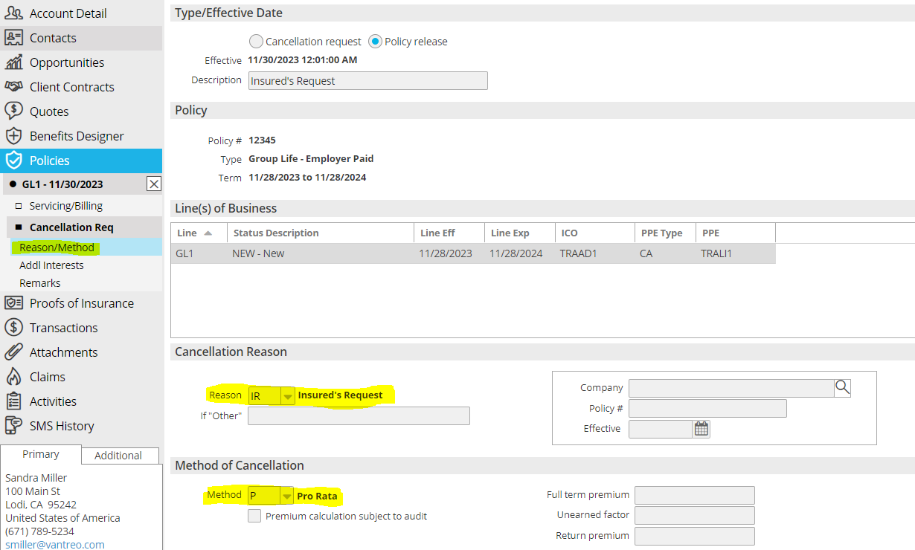

1. X out of Policy (from the left navigation panel)
2. Select Policy > ACTIONS > Issue Cancellation
3. The Status Description will auto-default to **CRN/CRR** depending on the status of the policy canceled.

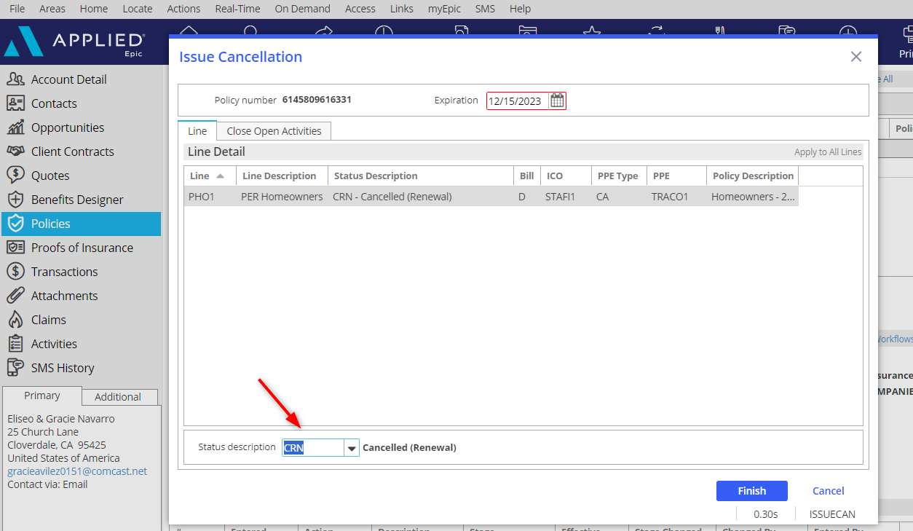

1. Click Finish
2. Double Click on policy
3. In the left panel, click **Servicing/Billing > Line** and update “Line ID” with reason for cancellation (Lost to BOR)
4. Close **CPOL** activity as Unsuccessful, choose Lost reason, and click Finish.

#### Cancellation Confirmation Received from Carrier

**Download:**

* Attach Cancellation Confirmation to the **CPOL/CREW** activity—update the description and select the folder.
* Will update the service summary stage to **Cancelled.**
* Verify policy status: click Servicing/Billing > Line from the left navigation panel and verify/update the **policy status to Cancelled – CRN/CRR** (select based on original status).
* Close the **CPOL** activity as **Unsuccessful** and select the reason; click Finish.

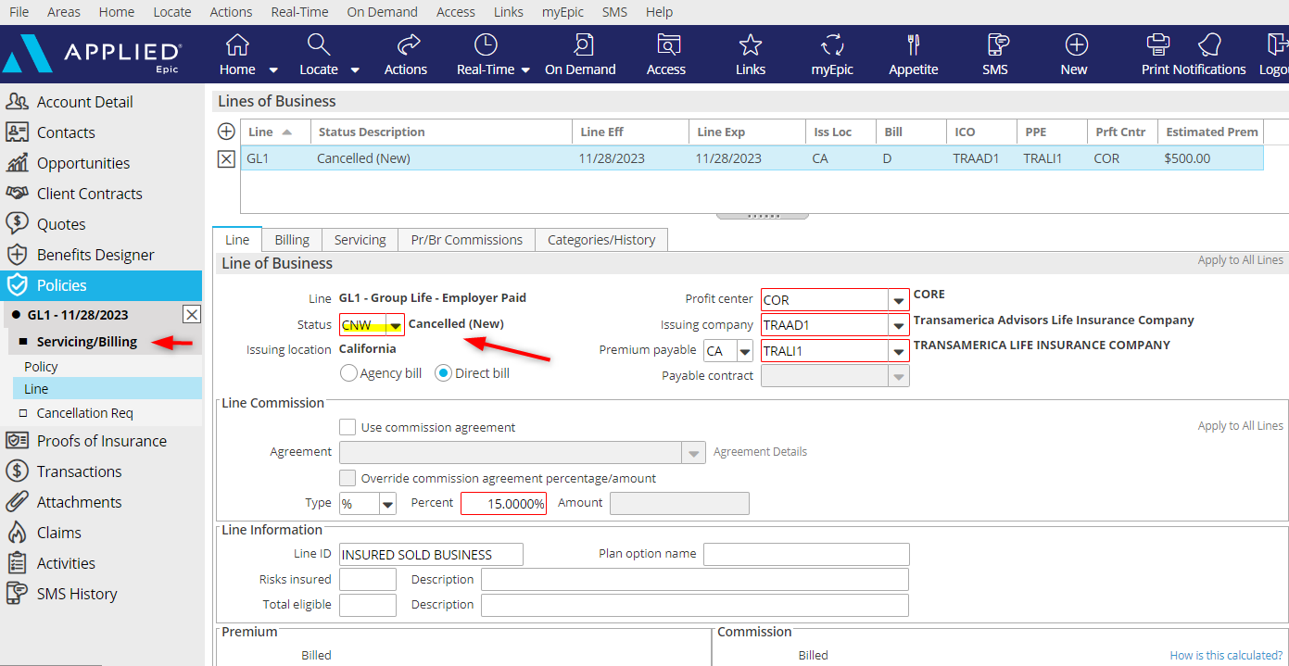

**Non-Download:**

* Attach Cancellation Confirmation to the **CPOL/CREW** activity—update the description and select the folder.
* Select Policy then **ACTIONS** > **Issue Cancellation** – verify details.
* **The policy status will automatically update to Cancelled – CRN or CRR** (based on original status) only for the line being canceled.
* Attach **BOR** Confirmation to the activity – update the description and select folder.



* Click the **Close Open Activity** tab and close the **CPOL** activity as **Unsuccessful** and select reason; add notes; click Finish.

**Notice of Cancellation for Non-Payment**

|  |
| --- |
| **Notice of Cancellation for Non-Payment Received**   * When a midterm notice of intent to cancel for Non-Payment is received, go to the Policies area in the Client’s account. * Click Policies in the left navigation pane. * Highlight the policy in question from the policy list view. * Click the **NEW** button in the top blue options bar and select Activity (or press F9) * Select the **PCN2** activity.      * Add Notes * Click Detail * Drag and Drop the Pending Cancel notice into this activity. * Update the Attach To description following your Platform’s document naming conventions      * Click **Finish** * Follow the appropriate steps below based on whether the client did or did not make payment.   1. If a client makes payment by the due date, drag & drop the carrier Rescind Notice to the open PCN2 activity on the Home Base. Update the description according to the Platform’s naming conventions. Add to the folder as needed.      + Right-click on the activity and select Close.      + Mark as **Successful**      + Add Final note (i.e., Payment received – cancel notice rescinded)      + Click **FINISH** * If a client does not make payment by the due date, drag & drop the carrier Final Cancel Notice to the open **PCN2** activity on the Home Base. Update the description according to the Platform’s naming conventions. Choose the Cancellation Sub-folder. * **IF cancellation is Downloaded** * Review Status * Open policy and from the Left Navigation Pane, click **Servicing/Billing>Line** and update “Line ID” with the reason for cancellation. * Close the open **PCN2** activity as Unsuccessful and choose Lost Reason.   + **IF Cancellation is Not Downloaded:**     - Locate Account – Select Policy -- **ACTIONS > Cancel**     - Select Policy Release—Enter the Effective date of Cancellation and description     - Click Finish     - Activity: CPOL**-** Add notes (who, what, where, when, how)     - Select Policy, then **ACTIONS** > **Issue Cancellation** – verify details.     - The Status Description will auto-default to **CRN/CNW** depending on the status of the policy, canceled.      * + Click Finish and double-click on the policy.   + In the left panel, click **Servicing/Billing > Line** and update “Line ID” with reason for cancellation (see below)      * + Click the **Close Open Activity** tab and close the **CPOL** activity as **Unsuccessful** and select reason; add notes; click Finish.   **If Agency Bill Return Premium:**   * Create $IN1 activity for the invoicing team * Create a $CRR activity with instructions on how to manage the funds when they are received. * Return to Insured * Send to Finance Company * Hold funds on account |

**Notice of Cancellation from Carrier**

|  |
| --- |
| **Notice of Cancellation for any reason other than Non-Payment I.E. N*on-compliance for Audit, Loss control requirements, Underwriting, Inspection, Conditional and Non-Renewals:***   * When a mid-term notice of intent to cancel is received, go to the Policies area in the Client’s account. * Click Policies in the left panel. * Highlight the policy in question from the policy list view. * Click the **NEW** button in the top blue options bar and select Activity (or press F9) * Select the **PCN1** activity.      * Label the activity as follows: * YY-YY Line of Business Cancellation Eff MM-DD-YY, Reason * Click on Save & Go to Detail * Code the **PCN1** Activity to AM and leave the Follow-up/Start date to the same day as entered in the system. * Drag and Drop the Pending Cancel notice into this activity and label the Document as follows:   + YY-YY Line of Business Cancellation Eff MM-DD-YY, Reason * Add Notes and Click Finish * Follow the appropriate steps below based on whether the client did or did not provide the requirements. * If a rescission notice is received, drag & drop to the open **PCN1** activity on the Home Base. Update the description according to the Platform’s naming conventions. Add to the folder as needed.   + - Right-click on the activity and select Close.     - Mark as **Successful**     - Add Final note (i.e., Payment received – cancel notice rescinded)     - Click **FINISH** * If the final cancelation notice is received, drag & drop to the open **PCN1** activity on the Home Base. Update the description according to the Platform’s naming conventions.  Choose the Cancellation Sub-folder. * **IF cancellation is Downloaded** * Review Status * Open policy and from the Left Navigation Pane, click **Servicing/Billing>Line** and update “Line ID” with the reason for cancellation. * Close the open **PCN1** activity as Unsuccessful and choose the Lost Reason.   + **IF Cancellation is Not Downloaded:**     - Locate Account – Select Policy -- **ACTIONS > Cancel**     - Select Policy Release—Enter the Effective date of Cancellation and description     - Click Finish     - Activity: CPOL**-** Add notes (who, what, where, when, how)     - Select Policy, then **ACTIONS** > **Issue Cancellation** – verify details.     - The Status Description will auto-default to **CRN/CNW** depending on the status of the policy, canceled.      * + Click Finish   + Open the policy   + In the left panel, click **Servicing/Billing > Line** and update “Line ID” with reason for cancellation (see below)      * + Click the **Close Open Activity** tab and close the **CPOL** activity as **Unsuccessful** and select reason; add notes; click Finish.   **If Agency Bill Return Premium:**   * Create $IN1 activity for the invoicing team * Create a $CRR activity with instructions on how to manage the funds when they are received * Return to Insured * Send to Finance Company * Hold funds on account |

## Policy Reinstated Workflow

### Reinstate Policy

|  |  |  |  |  |  |  |  |  |  |  |  |  |  |  |  |  |  |  |
| --- | --- | --- | --- | --- | --- | --- | --- | --- | --- | --- | --- | --- | --- | --- | --- | --- | --- | --- |
| |  |  |  |  |  |  |  |  |  |  |  |  |  |  |  |  |  |  | | --- | --- | --- | --- | --- | --- | --- | --- | --- | --- | --- | --- | --- | --- | --- | --- | --- | --- | | **Download:**   |  | | --- | | **Download will automatically amend your policy/line status to Renewal. If the original policy status was other than Renewal, status will need to be updated appropriately.**  **If a policy status is Cancelled, it will NOT show up on your expiration reports or create system generated renewal activities.** |      * Review **Download Report** and/or open **ZREI** or **ZRNR** activities. * Download will **automatically** update the: * Service Summary Stage to **Reinstated** * Expiration date to the original **Expiration Date** * Policy Status to **REN** - **Renewal** * Policy status will need to be verified: from left navigation panel click **Servicing/Billing > Line** and update the policy status to the appropriate “New” or “Renewal” option:  |  |  |  |  | | --- | --- | --- | --- | | **NBR** | New - BOR | **REN** | Renewal | | **NEW** | New | **REW** | Renewal – Rewrite (First renewal w/new carrier) | | **NX1** | New – Cross Sell – Under 10K | **RX1** | Renewal – Cross Sell – Under 10K | | **NX2** | New – Cross Sell – Over 10K | **RX2** | Renewal – Cross Sell – Over 10K |  * Mark task on **ZREI** or **ZRNR** as completed and close Activity as **Successful**, add notes and click Finish * If closed, reopen the **ZCAN / ZNON**Activity and close as **Successful**; add notes and click Finish. * If there is an original closed **CPOL or CREW** Activity; Reopen Activity, then close as **Successful**; add notes and click Finish.   **Non-Download:**   * From the client’s account, click Policies from the left panel * Select the CANCELLED policy to be reinstated * Click **ACTIONS > Reinstate** * Enter date the policy was reinstated * Add Description * Click Finish * Activity = **REIN**: Add detailed notes as to why the policy was reinstated   + Close Activity Successful; click Finish * Verify the Policy Status was updated correctly per the original Policy Status * If there is an original closed **CPOL** Activity; Reopen **CPOL** Activity then Close as Successful | |

## Policy Not Renewed Workflow

***If a policy non renews at expiration and is not rewritten with our Agency…Examples below:***

1. ***Insured calls/emails and states that he/she will not be renewing with our agency.***
2. ***Non-renewal received from a carrier, and we are unsuccessful in rewriting* *with another carrier.***

### Mark Policy as Not Renewed

|  |
| --- |
| * Create **PCN1** activity & set Follow-up/Start Date to the policy expiration date.   + Add notes as to why the policy was not renewed. * When **PCN1** appears on Follow up/Start Date go to the Policy screen and double click the policy which is not renewing * In the left panel, click **Servicing/Billing > Line.** * **Update the policy status:** (Select based on original policy status)   + **NRN** (Not-Renewed NEW) -The Policy was a new business.   + **NRR** (Not Renewed REN) -The policy was a renewal. * Add note to Line ID: Example: No response from the client.   A screenshot of a computer screen  Description automatically generated   * Click the X on the left navigation panel and click Finish * Click Finish * Close **PCN1** Activity as **Unsuccessful – Lost – Reason** * If the Account no longer has any active policies open **GNRN,** set Who/Owner to workgroup **PLLEAN**, and set follow-up/Start date for 60 days from the final policy expiration date |

## Policy Not Renewed for BOR

### Mark Policy as Not Renewed

|  |
| --- |
| * Create **PCN1** activity & set Follow-up/Start Date to the policy expiration date.   + Add notes as to why the policy was not renewed. * When **PCN1** appears on Follow up/Start Date go to the Policy screen and double click the policy which is not renewing * In the left navigation pane, click **Servicing/Billing > Line.** * **Update the policy status:** (Select based on original policy status)   + **NRN** (Not-Renewed NEW) -The Policy was a new business.   + **NRR** (Not Renewed REN) -The policy was a renewal. * Add a note to Line ID: Example: Lost to BOR.   A screenshot of a computer screen  Description automatically generated   * Click the X on the left navigation panel and click Finish. * Close **PCN2** activity as **Unsuccessful – Lost - BOR** * If the Account no longer has any active policies open **GNRN,** set Who/Owner to workgroup **PLLEAN**, and set follow-up/Start date for 60 days from the final policy expiration date |

## Claims Workflow

|  |
| --- |
| **(Future State) If referring Claims to the Platform Centralized Claims Department:**   * Highlight the policy * Click NEW Activity (or F9) and select **PCRF** * Assign to Claims Team for handling (Who/Owner = CLM Work Group) * Add notes regarding conversation with client; leave open, click Finish |

### Add New Claim

|  |
| --- |
| 1. Locate Account 2. Click **NEW** Claim    * When receiving **claims download**, enter data in required fields only. Download will populate claims details.    * If **NOT receiving claims download**, manually enter all details. 3. Click **Detail** 4. **ACLM** Activity – leave open for follow-up.    * Add notes (who, what, where, when, how, why, etc.) - Click **Finish**. 5. Click all screens in the Navigation Panel to enter claim details 6. Click the X in the left panel to close out the claim detail 7. To **Issue a Loss Notice**, highlight the claim; click **ACTIONS > Issue Loss Notice**  * Click the Distribution tab * Select Contact (use the lookup button to locate) * Select Via (Print, Email) and enter additional details * Click **Finish**  1. Attach all claims documentation to the **ACLM** Activity |

#### Claim Updates

|  |
| --- |
| 1. Double-click the Claim to open the left panel 2. Click the section to be updated (i.e., Claim Payments, Update Reserves, Enter Subrogation or Litigation Detail, etc.) 3. Click the X in the left panel to close out of the claim detail 4. To add notes to the **ACLM** Activity:    * Click once on the claim from the list view    * Click **ACCESS > Activity – Open Activities**    * Add notes, Click Finish |

#### Close Claim in Epic when Claim closed by Carrier

|  |
| --- |
| 1. Select Claim 2. Click **ACTIONS > Close Claim**; add close date, and click Finish 3. With the claim highlighted, click **ACCESS > Activity – Open Activities**    * Select the open **ACLM** Activity    * Add notes    * Mark as Closed – Successful    * Click Finish |

## Add Attachment

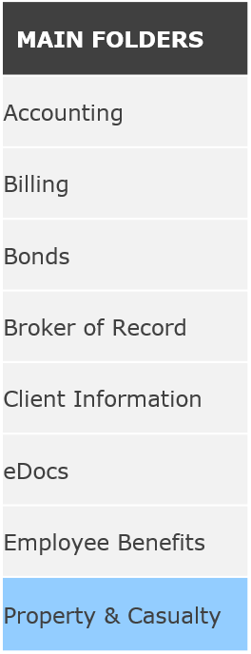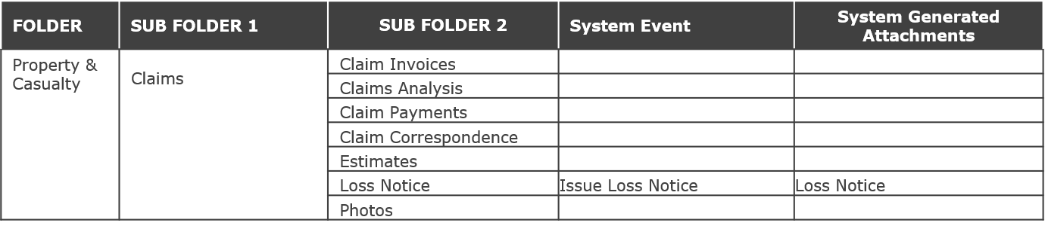

# Client Contracts/Services Workflow

**\*\*This area allows the recording of fee-based agreements. These are used for Service/Consulting Agreements and fees in Lieu of Commission Agreements.**

|  |  |  |  |  |  |  |  |  |  |  |  |  |
| --- | --- | --- | --- | --- | --- | --- | --- | --- | --- | --- | --- | --- |
| 1. Locate Client’s Account 2. On the left Navigation Panel, click Client Contracts 3. Click Services 4. Click the **ADD** button. 5. Select a **Service Code** from the dropdown menu.  * Many codes will have 2 options, one for an annual fee and one for a one-time fee.  |  |  |  | | --- | --- | --- | | **CODE** | **DESCRIPTION** | **DEPARTMENT** | | *FLP | PL Fee in Lieu of Commission | PEL, PEM, PES | | RCFZ | Flood Zone Correction (ARR) | ARR | | RCIN | Inspection (ARR) | ARR |  1. Enter the Contract number, if applicable  ***NOTE: When adding a New Service and including billable fees if there isn’t a policy association, be sure to add #NEW in the Contract Number field.*** 2. Enter the Description of the Service provided. 3. Enter the term of service from the dropdown menu and the inception and expiration dates.  * The inception and Expiration date should match what is on the fee agreement signed by the client. * If there isn’t an expiration date, use the month and day of the inception and make the year 9999. * If a single event, the Term should be Other, and the inception and expiration date should be the date the service will be performed.  1. **Be sure to enter the correct Agency/Branch & Department** 2. Click DETAIL 3. **ADSC** Activity defaults    * Verify Who/Owner    * Defaults as Closed, but mark as Open if follow-up is needed and verify follow-up/start date.    * Add Notes 4. Add Type of Fee (Flat or Hourly) 5. Enter contracted fee / contracted hours as needed. 6. Click the **Association** tab: Click ADD to associate this service with existing client policy(ies) 7. Click the **Itemizations** tab: Click ADD   - Enter the description of the service  - Name of the person who provided the service  - Account Contact  - Mileage (if applicable)  - Hours of service provided  - Hourly rate  - Calculate total   1. Click the Servicing Tab:  * Enter Product Producer & Product Servicer  1. Click the PR/BR Commissions Tab:    * Click ADD if someone will be receiving commission on the service fee and enter their percentage of commission and production credit 2. Click Attachments from the Navigation Panel and click the **ADD** button to add any attachments associated with the service (i.e., Service Contract, etc.) 3. When finished, close the Service from the Navigation Panel 4. Create an Accounting Activity that corresponds with the Client Contract/Service  * Highlight Service>Click F9 to add Manual Activity * Attach the signed fee agreement for INVO team to provide the invoice.  1. Once a Service Contract is expired, close the contract – **Actions>Close Service** |

# JOB AIDS

## JA.1 Marketing Module Lite (New or Renewal Business) QNEW/QREW PER EACH CARRIER

### Add Master Marketing Submission

1. Click the **Policies** area from the left Navigation Panel of the Client’s account.
2. Change policy view from **Current** to **Marketed**



1. Click the **ADD** button (+)
2. Enter a name for the Submission (Name: 24-25 Master Submission)
3. Enter required information (Department & type of business)

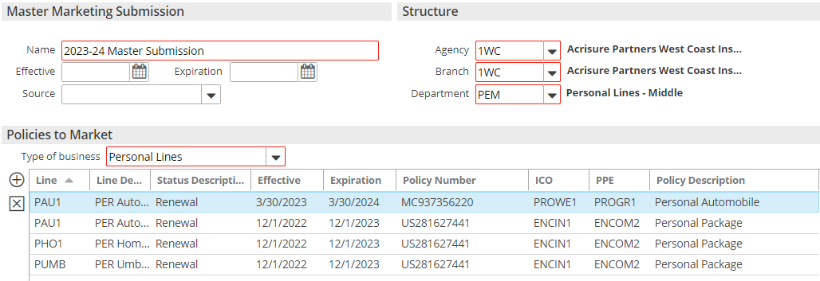

1. Add policies to the submission by clicking the **ADD** button under Policies to Market
2. **Add New Line**—Create new policy(ies) for marketing or,
3. **Add Existing Line** – Marketing existing lines. Check all policies going out to market. **Include ALL lines of business going out to market.**
4. Click **DETAIL**
5. The **AMMK** Activity will auto-set to Closed as Successful; click Finish.
6. Click the **ATTACHMENTS** Tab and drag & drop or click the (+) to add existing Client Documents or browse your files outside of Epic for attachments to be included in the submission.

1. Enter/update policy details by clicking each line in the navigation panel and completing/updating each of the screens to fill in details in the ACORD apps (be sure to add detail to the Personal AP/ACORD 88 first)
2. When finished, close Submission from the navigation panel (X)

### Add QNEW (New Business) or QREW (Renewal) Activity for each Carrier.

1. From the **Policies Marketed** list view, highlight the Master Submission
2. Click the **NEW** button at the top in the blue bar; select **Activity** (or press F9)
3. Click **Continue**
4. Code = **QNEW or QREW**
5. Description = Add Carrier name and Estimated Premium
6. Add the **Premium Payable** code in the **Detail area.**
7. Leave OPEN; add notes.
8. Click **Finish**
9. Repeat Steps 1-8 for **each** carrier.

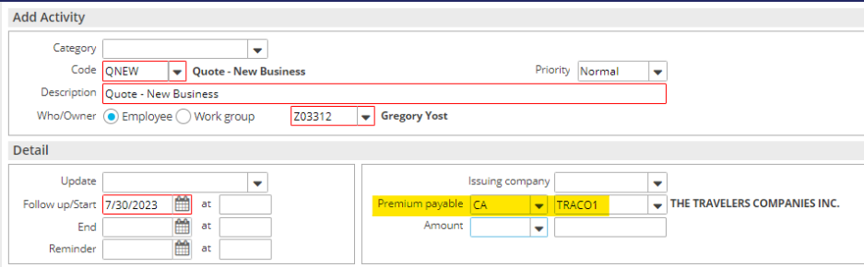

**IMPORTANT! – Be sure to add this information**

### Send Applications to Carriers

#### Save & Submit ACORD Applications

1. Right-click on the Master Marketing Submission created above.
2. Select **Review Application**
3. Select the “Master Marketing Submission” radio button; click **Continue.**
4. Click the **Organization Contact** tab and verify/update the agency address.
5. Click the **Distribution** tab.
6. Under **Delivery Options** select **“Attach Without Distributing”**
7. Click **Finish**
8. With the submission highlighted, click **ACCESS >** **Attachments**, **right-click** on the ACORD, and select **Send Via Email** if emailing to the underwriter.
9. If quoting online, add notes to the specific carrier’s Open **QNEW** or **QREW** Activity.

#### Attach quote-related documents to QNEW/QREW

1. Drag & drop onto the **QNEW or QREW** activity all emails, documents, applications, etc. to the specific carrier **QNEW** or **QREW** Activity.
2. Select the **Marketing** Folder
3. Click **Finish** on the **Attach to** screen.

### Carrier Responses Received

1. Record carrier responses by adding NOTES in the **QNEW** **or QREW** activity for the appropriate carrier.
   1. Right-click on the carrier’s **QNEW** **or QREW** activity
   2. Select Add Note and enter a detailed note.
   3. If the carrier responded with a quote, enter the quoted amount in the amount field on the activity. Use “Premium Quoted” as the amount qualifier.

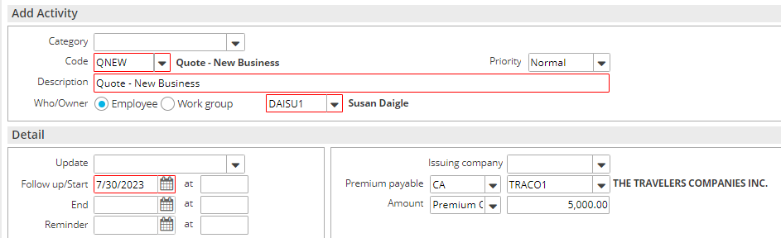

1. Drag & Drop Carrier emails to the carrier’s **QNEW** **or QREW** Activity

### Carrier Selected for Binding

1. When a carrier is selected for **binding**, close that carrier’s **QNEW/QREW** as **Successful** and add notes.
2. **All other QNEW or QREW** activities should be **closed as Unsuccessful**, select a reason, and add notes as to why the carrier declined, or why the quote was rejected.

### Move Binding Carrier Submission to Current Policies

Follow these steps in order **- ONLY FOR THE BINDING CARRIER:**

1. Right-click the Master Submission and select **Create Carrier Submission**
   1. Premium Payable = select the binding carrier
   2. Submission Status = Completed
   3. Click **Finish**
2. Right-click the Master Submission and select **Update Stage to Entered/Submitted**

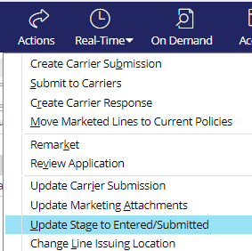

1. Click **Finish**

***The steps above must be done to Generate an Epic Proposal.***

1. Right-click the submission and select **Create Carrier Response**
   * Description = Quoted / Bound
   * Date Received = current date
   * Carrier Response = Quote
   * Enter Response Line Premium, carrier commission rate, and click **Calculate**
   * Click **Finish**

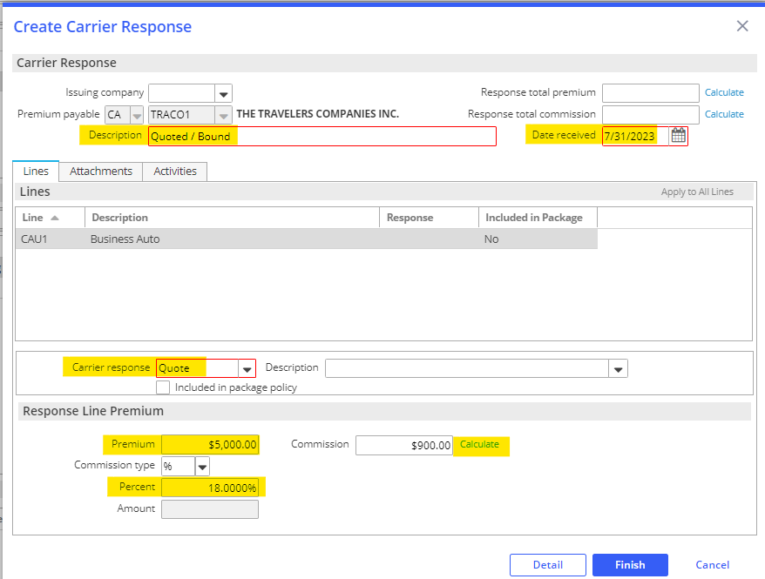

* + On the popup, select Yes Perform Action and select **Move Marketed Lines to Current Policies**

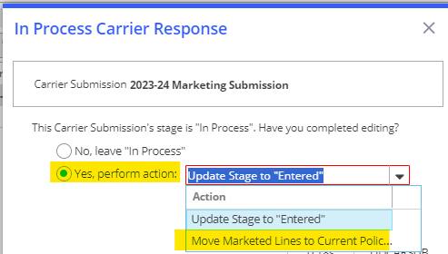

***Policies Tab****:*

1. Select **Add new Policy for New Business** or **Renew existing policy** (to keep the lineage of the original policy)
2. Enter Policy Line, Description, Effective & Expiration Dates (if choosing to Renew existing policy above, click the drop-down to search for the appropriate policy)
3. Update Stage to **Submitted** or **In Process** (if policy detail edits are needed or if an invoice is required to bind).
4. Select **Contracted** policy unless an invoice is required to bind then choose **Prospective**.

***Lines Tab:***

1. Select the lines to add to the new policy, renewal, or existing policy.
2. Select either
   * **Add to this policy** - Add the line to the policy added under the Policies tab
   * **Add to a** **different policy**
   * **Do not add to any policy.**

* Keep in mind, that the choices made here affect only the highlighted line.
* Use **Apply to All Lines** if the choices apply to all lines, not just the highlighted line.

1. Under the **LINE** tab, select Status = NEW; enter Issuing Co (writing co); enter carrier commission rate.

1. **Billing** tab – verify the Contact (whoever is to populate on an agency billed invoice)  
   A screenshot of a computer

   Description automatically generated

* If the contact is not correct, click on the magnifying glass and choose the correct Contact from the Contact area:
* Delivery Method should always be **Mail** so when an invoice is transacted it is not emailed to the client without any explanation.

1. Click the **SERVICING** tab – verify the employees in each servicing role.

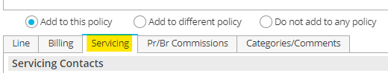

1. Click the **PR/BR COMMISSIONS** tab.

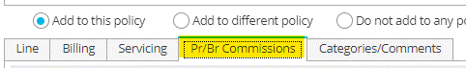

* + Click the **ADD** button to add the producer who will be paid a commission on this policy.
  + Producer Commission will default, if there are any discrepancies please reach out to your REA – Regina Kanen and SA – Eric Trueblood for guidance.
  + Production credit should be 100%.

1. When finished, click **MOVE.**

* Update Submission status to Completed; click **Finish.**

1. **BND1** Activity – Bind Policy via Master Marketing
   * Leave open for receipt of the policy.
   * Add Notes and click Finish.
2. Change Policy view from MARKETED to CURRENT

### Policy Received from Carrier

1. Drag & drop the policy dec to the appropriate **BND1** Activity and check mark as **Important Policy document**.
2. Policy Check for accuracy: Reassign **BND1** activity to 3rd Party/Workgroup to attach Policy for Policy Check
   * When the policy is attached to the **BND1** Activity, **Mark as an Important Policy Document** – this will automatically attach to the policy and activity.

* + If the Policy is inaccurate, leave **BND1** open for follow-up; send to carrier or account servicer for correction.
  + Processor will create a note when the policy checking is complete.

1. Issue the Policy in Epic:
   * Highlight the policy.
   * Click **ACTIONS > Issue/Not Issue Policy** and **Issue**
   * Verify Policy #, Effective/Expiration Dates, and Policy Status (**NEW/REN/REW**)
   * Click the **Close Open Activities** tab close the open **BND1** activity as Successful and add a final note.
   * Click **FINISH**

**JA.2 Opportunities**

***This job aid shows how to set up an opportunity, update opportunity, and navigate the Dashboard and Opportunities sections on your home screen.***

|  |
| --- |
| **TIP:** First you will want to go to **Home<Configure<User Options<Customize Homebase<Select Dashboards and Opportunities** to show on your Home Base |

**Creating a new Opportunity**

|  |
| --- |
| **TIP:** If opportunity pertains to a new client, a new prospect must be created prior to creating the opportunity.  **TIP:** A Sales Manager and Sales Team needs to be created before they can set up a new opportunity. Send request to [support@acrisure.com](mailto:support@acrisure.com) |

1. Under client/prospect select **Opportunities** on the left navigation panel

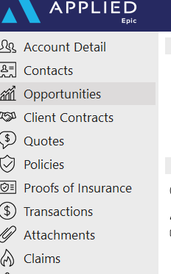

1. To create a new opportunity, select the **+** to start.

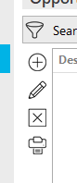

1. Complete sections of the **Opportunity Detail.** Remember **RED** sections are required fields
   1. Select whether the Opportunity is New or Renewal
   2. Type brief description of what business you are trying to obtain
   3. Enter target close date (salespeople will know what this means)

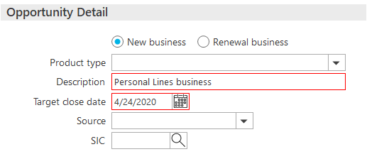

1. Add a department to the **Structure** section.

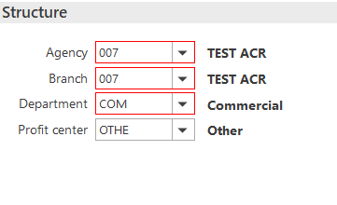

1. Complete the **Estimated Value** section.
   1. Make sure you fill in estimated **Revenue** since this is what pulls to your **Dashboard**, but other information may be entered

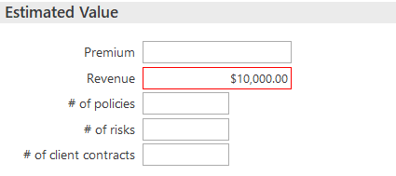

1. Choose your **Sales Team** and the **Owner** of the **Opportunity**. The Owner could be you as the servicer, or it could be the producer if entering on behalf of the salesperson.

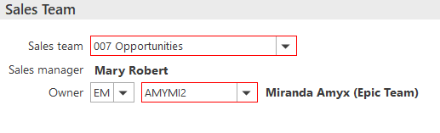

1. Complete **Stage Details** to show what stage you are in your Opportunity.
   1. Choose your Stage Group if you have one created for your team. If not, you can use **Default Group**
   2. The **Stage** identifies the opportunity’s position in the sales pipeline*.* It also updates the percent of probability of winning the Opportunity.

1. Use the **Comments** section to add any other information pertaining to this Opportunity. Click **Detail** when done.

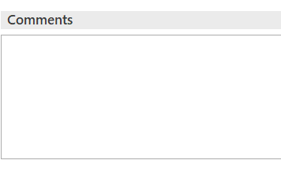

1. An automatic AOP activity will be created and set to open to document and attach documents and correspondence.
2. More information sections will appear on your left **Navigation Panel**.

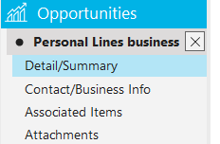

1. In the **Detail/Summary** section, there is a **Categories** tab. You can add **Agency Defined Categories** for your Opportunity if desired.
   1. Add a Category by selecting the **(+)**

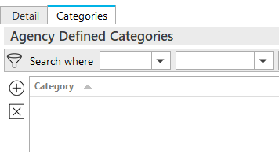

1. Under **Contact/Business Info**, you will addthe nameof the individual in contact with about this Opportunity.
   1. You will use the **+** button to add their information.

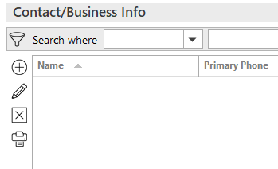

1. Under **Associated Items**, you can associate this Opportunity with a current **Marketing Submission,** **Policy**, or **Service**.
   1. You will use the **+** button to add this information.

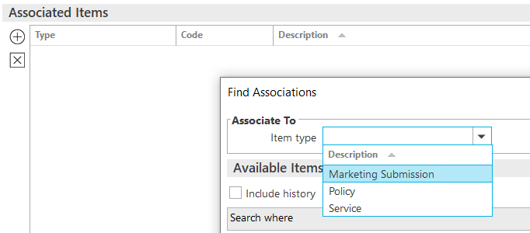

**Updating the Opportunity**

**Opportunity**

|  |
| --- |
| **TIP:** As you are working on your Opportunity, you will want to update the Stage, add documents, and maybe update Comments. |

1. From your **Home** screen, your created Opportunities will show in the **Opportunities** section. You can view by **30 Days, 60 Days, 90 Days**… From this section, you can click on the blue link, and it will take you to the **Opportunities Detail** or **Right Click** and update~~d~~ *the* information from there.
   1. **Add Activity** – Add an F9 activity
   2. **Change Stage** – Updated your stage
   3. **Change Stage Group** – Amend your Stage Group
   4. **Close** – Close your Opportunity either Won or Loss
   5. **Renew** – Renew your Opportunity

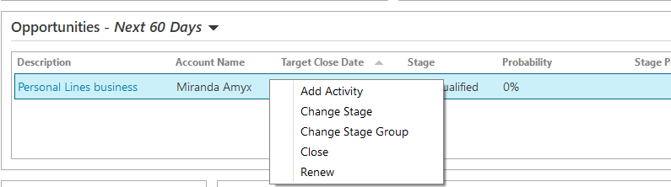

1. As you work through your Opportunities, update the Stage to keep the Dashboard updated.
   1. Each time you select to **Change Stage**, it will automatically update to the next **Stage** in your **Group.**

1. Once an **Opportunity** is complete, you can **Right Click** on the Opportunity, and then **Close**.



1. Once you have selected **Close**, you will choose **Lost** or **Won**. If **Opportunity** is lost, choose a **Reason** for the loss. Once done, click **Finish**.

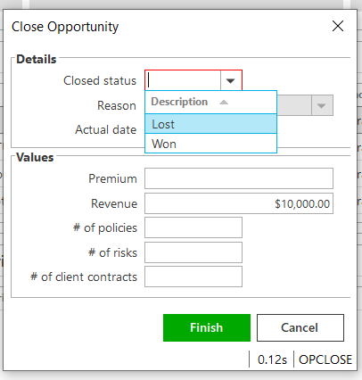

1. An **Automatic Activity** will appear. Select which code applies, add notes, and then **Finish** out Activity.

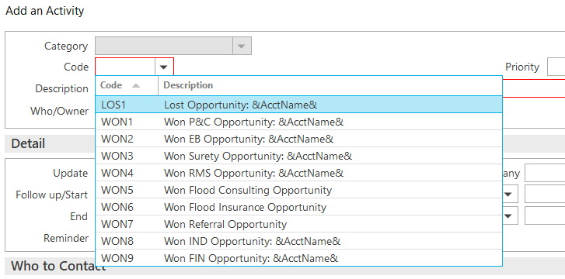

**Working through the Dashboard**

Your Home screen will show your **Dashboard**. As a team manager, you will have the opportunity to look at each team member's Dashboard

|  |
| --- |
| **TIP:** Double-clicking on each graph will provide more detail about that information. Dates and values can also be changed in the more detailed view.  **TIP:** Graphs default to Revenue. |

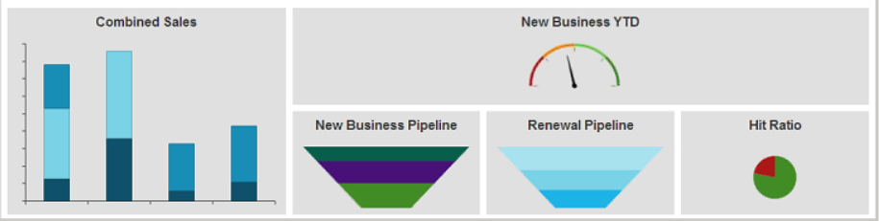

* **Combined Sales**
  + This shows up to 150 Days of new & renewal **Opportunities** and expiring policies you have.
* **New Business YTD**
  + Shows your sales goal that was set and your status with that sales goal.
* **New Business Pipeline**
  + This will show you the new business opportunities and where you are in the different sales stages. You may change your target date if needed.
* **Renewal Pipeline**
  + Shows your upcoming renewals and renewal **Opportunities.**
* **Hit Ratio**
  + This section will give you the Opportunities you have won and/or lost

## JA.3 Renewal Manager

### Renewal Stages

***Details in the Renewals Manager view are related to the expiring policy.***

|  |  |
| --- | --- |
| **Stage Description** | **How it functions** |
| **Renewal Not Started** | Tied to the Event: **Policy Created** (display policies with this stage in the RM "**0**" days after expiration) |
| **Pre-Renewal In-Process** | Manual - (display policies with this stage in the RM "**30**" days after expiration) |
| **Submitted For Quote** | Manual - (display policies with this stage in the RM "**30**" days after expiration) |
| **Quote Received** | Manual - (display policies with this stage in the RM to "**30**" days after expiration) |
| **Proposed** | Manual - (display policies with this stage in the RM to "**30**" days after expiration) |
| **Renewal In-Process** | Tied to the event: **Policy Renewed** (display policies with this stage in the RM "**30**" days after expiration) |
| **Renewed** | Manual - (display policies with this stage in the RM "**0**" days after expiration) |
| **Did Not Renew** | Tied to the event: **Policy Cancelled** (display policies with this stage in the RM "**0**" days after expiration) |

### Renewal Events

#### Policy Created

This Event is responsible for a new policy as well as a renewed policy to be given the Stage “Renewal Not Started.” This Stage begins the renewal effort. Policies coming up for renewal will show in the RM, in advance of the renewal date with the Stage “Renewal Not Started,” according to the time frame assigned to the policy type.

* 120 days for commercial lines policy types
* 60 days for personal lines policy types
* 90 days for employee benefits policy types

#### Policy Renewed

This Event is tied to the Actions>Renew process. When the expiring policy (the current term…the policy currently being worked for renewal) is renewed (via Actions>Renew), the expiring policy (i.e., the current term… the policy currently being worked for renewal) will be given the Stage Renewal In-Process. The renewed policy (i.e., the policy created through the Actions>Renew process) will not show in the RM but will show in the Policy list view (e.g., Policies – Current/Renewed). The renewed policy will be given the Stage “Renewal Not Started.” This Stage should remain as is until ready to work on the policy renewal the following year. The renewed policy (i.e., the one created via Actions>Renew) will need to be Issued as normal. The Stage given to the expiring policy (i.e., the current term… the policy currently being worked for renewal) will need to be changed, by the user, to Renewed once the renewal policy has been Issued. This Stage “Renewed” will be the final Stage given to the expiring policy in the RM. An expiring policy with the Stage “Renewed” will drop from the RM view on the expiration day.

#### Policy Cancelled

This Event is tied to the Actions>Cancel>Issued process. The Stage shown on a policy cancelled via the Actions>Cancel>Issued process will be Did Not Renew. Note: if the policy is reinstated, the Stage will automatically revert to the Stage it was assigned to before it was cancelled.

### Renewal Manager Workflows

#### View Renewals

1. From **HOME** screen select **Renewals Manager** from Navigation Bar

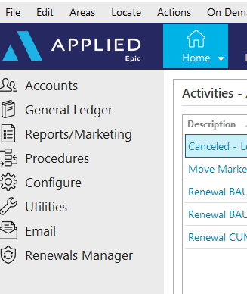

1. Assigned Servicers accounts will be displayed with a **Renewal Not Started** Renewal Stage

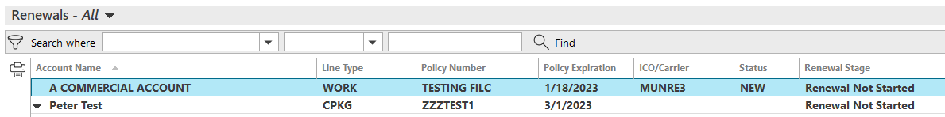

* **Personal Lines**: 60 Days prior to expiration
* **Commercial Lines**: 120 Days prior to expiration
* **Employee Benefits**: 90 Days prior to expiration

1. Click once on renewal to select:



* **Go to Policy** – Moves directly into the policy under the client’s account
* **Renew** – Starts the renewal process from the client’s account
* **Marketing Submission** – Starts a marketing submission from the client’s account
* **Update Renewal Stage** – Allows for manual update to the renewal stage
* **Market Appetite** – Launches IVANS Market Appetite with list of possible markets

#### Renew Policy

1. Select **Renew** then refer to the **Renewal Process**/**Non-Downloaded Policies**section in the Workflows Document



1. Once renewal is started, the Renewal Stage will change to **Renewal in Process**
2. Manually update the stage as needed:

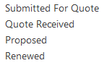

#### Marketing Submission

1. Select **Marketing Submission** then refer to the **Marketing Module** section in the Workflows Document



1. The Renewal Stage will NOT automatically update while working through the Marketing Module. The Renewal Stage must be updated manually by selecting **Update Renewal Stage.**



#### Canceled/ Non-Renewed Policies

**Cancelled Policies:**

1. Refer to the **Cancellations** section within the Workflows Document
2. Once **Cancellation** has been issued, the Renewals Manager Stage will automatically be updated to **DID NOT RENEW** and will drop off the Renewals Manager list

**Non-Renewed policies:**

1. Refer to the **Policy Not Renewed** section of the Workflows Document
2. The Renewal Stage will NOT automatically update after the Policy has been manually non-renewed. Update the Renewal Stage by selecting **DID NOT RENEW** from **Update Renewal Stage**. This policy will NOT drop off the Renewals Manager list but will stay for one day AFTER expiration

## JA.4 Proofs of Insurance

### EPIC Auto ID Cards

1. Select Policy
2. **ACTIONS > Issue Auto ID Card**
3. Highlight the appropriate vehicle—make sure there’s a Y under the Issue Column or Click Select to Issue if not
4. Click the Distribution Tab
5. Select Contact (use the magnifying glass to locate)
6. Select Via (Print, Email, Fax) and enter additional details
7. Click **Finish**—AUID Activity defaults closed

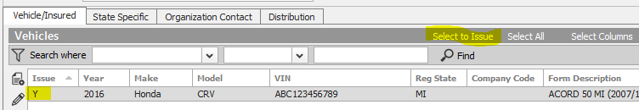

### EPIC Evidence of Property Insurance

#### Add New Evidence

1. Locate Account
2. Click the **NEW** button—Proofs > Evidence
3. Select the appropriate ACORD form; enter a Title
4. Under Type, select the appropriate policy and service summary row
5. Click **Detail**
6. Click each section and enter details
7. When completed, click **ACTIONS** > **Issue Evidence**
8. Click the Additional Interest Distribution Tab
   * Select Contact (use the magnifying glass to locate)
   * Select Via (Print, Email, Fax) and enter additional details
   * Click **Finish**
9. Click the X in the Navigation Panel to close the EPI

#### Renew Evidence

* + - 1. Locate Account
      2. Click Proofs of Insurance from the Navigation Panel
      3. Select Evidence
      4. Highlight the appropriate EPI
      5. Click **ACTIONS** > **Renew Evidence**
  + Select the renewal policy and service summary row
  + Select the lines of business to include
  + Check the defaults to include
  + Click **Detail**
    - 1. **Activity REVI** defaults closed—add notes, click Finish

#### Issue Single / New Additional Interest

* + - * 1. Locate Account
        2. Click Proofs of Insurance and select Evidence
        3. Click **ACCESS** > Activities—all activities
        4. Select the **REVI** Activity and review notes
        5. Click **ACCESS** **> Attachments** from the **REVI** Activity and review
        6. Click Proofs of Insurance and edit appropriate EPI
        7. Highlight the additional interest—click the **ADD** button to add new AI and detail
        8. Click **ACTIONS > Issue Singe Additional Interest**
        9. Uncheck Insured if not needed. Verify AI distribution.
        10. Click **Finish**

## JA.5 DocuSign Integration

**From Attachments in the Client’s account**:

1. Right-click the attachment and select **Send to eSignature**

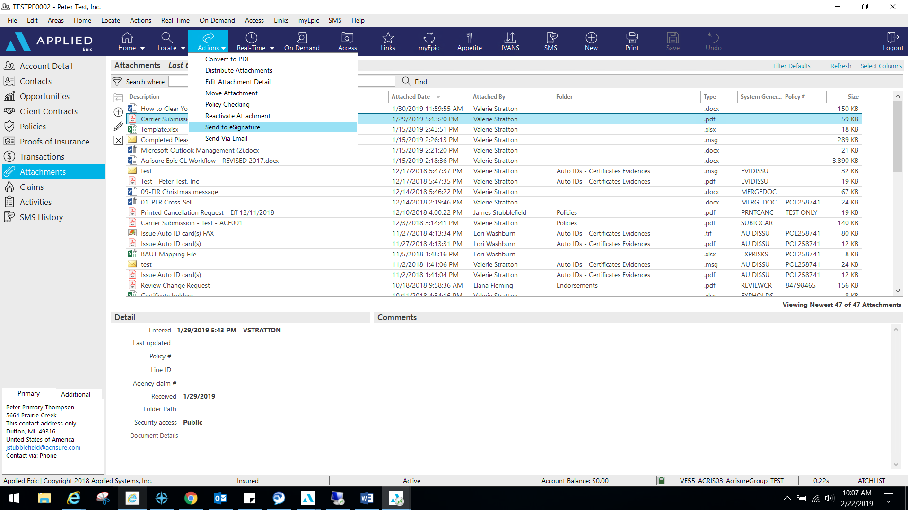

1. 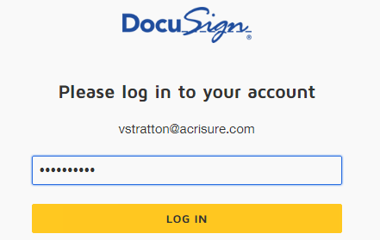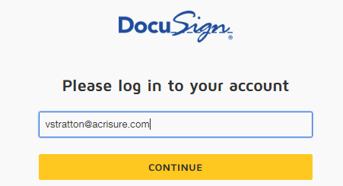Log into **DocuSign** using your email address and password.
2. Allow DocuSign permission to integrate with Epic.

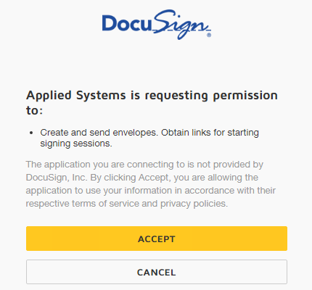

1. Select an Epic Contact; click the TO button

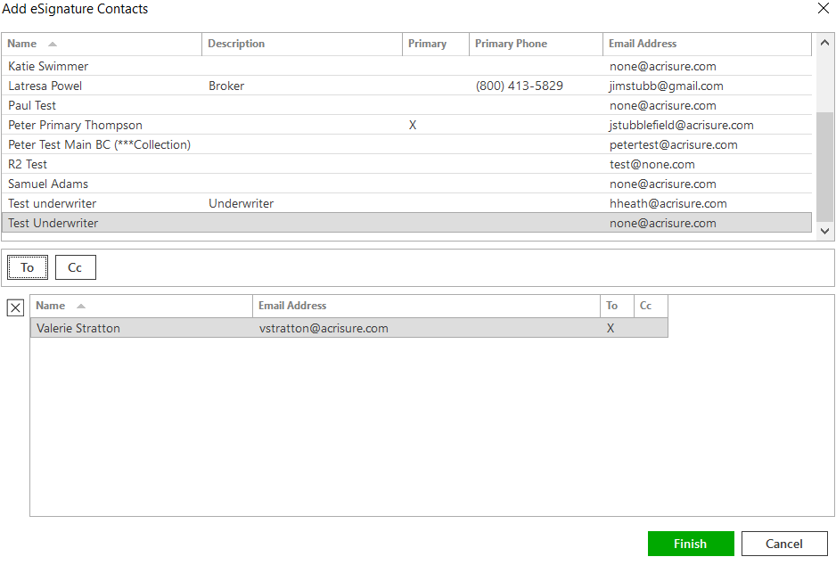

1. Please wait while Epic directs the document to DocuSign for signature fields.
2. Add appropriate fields for signature, date, text, etc. by dragging and dropping them onto the document.

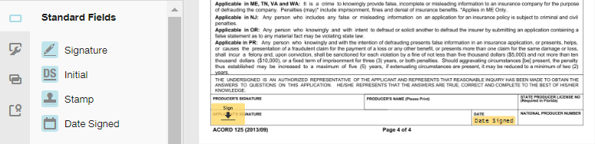

1. If using a template, remove the extra recipient. Actions>Edit Recipient

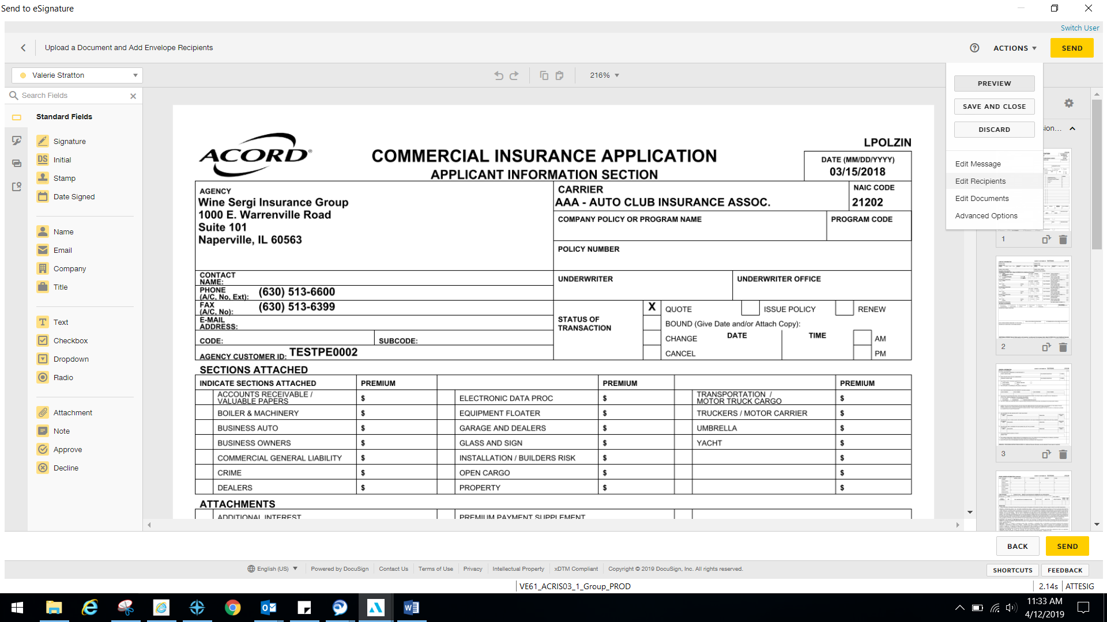

1. Once finished, select Actions>Edit Message.

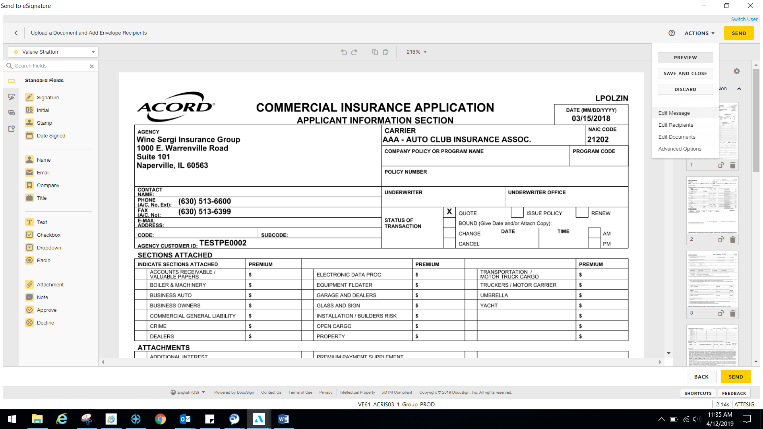

1. Edit the email subject line and personalized message to client and select Done.

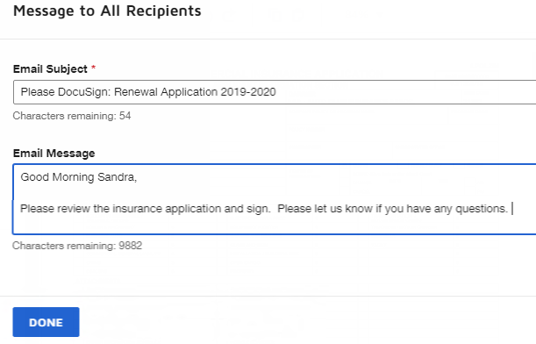

1. Select Send via the top right or bottom right corner when finished.

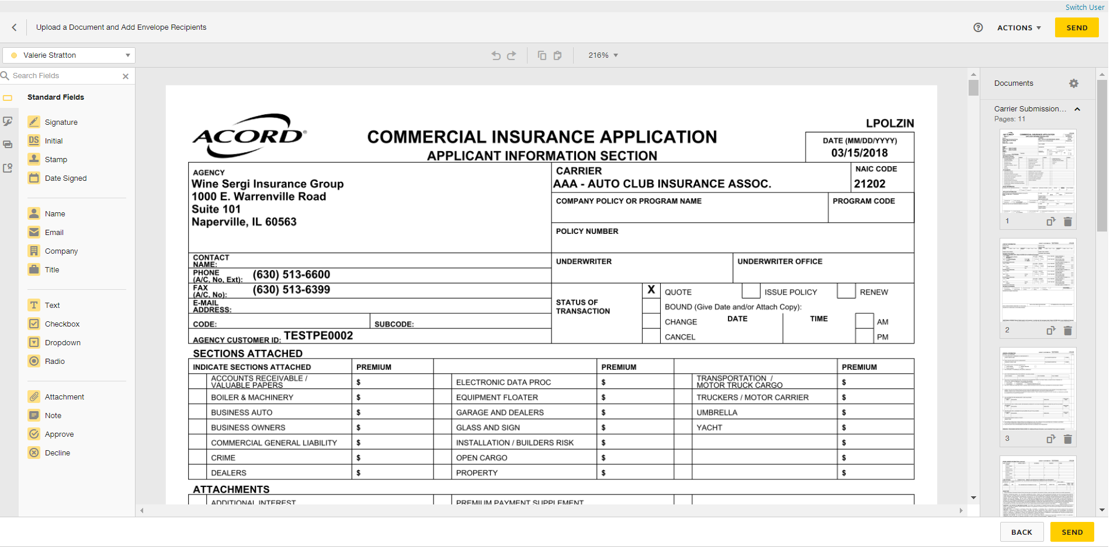

1. DocuSign will redirect you to sign into your account to manage your envelopes. Closeout when finished.
2. A system-generated **ESIG** activity will appear and is set to remain open for follow-up. If another activity is open and related to the process, close **ESIG** as successful.